Creator Studio

Creator Studio – Apps for anyone

Unlock development across the business

Introduction

Overview

ServiceNow Creator Studio offers a curated experience to build simple applications within guard rails on ServiceNow.

Goal

Get a glimpse of how Creator Studio works and be able to create a simple application with a playbook to guide a user working on a task.

Background

You support Jake, a marketing director In your organization. Jakes team is exceeding their goals, and Jake wants to reward them.

The company has a rewards process where a manager can request one of a number of different approved rewards to their team. The process however, is manual and time consuming today. Jake has asked you to recreate the process on ServiceNow using Creator Studio.

Lab

ServiceNow Instance Access

Log in to your instance using the details provided to you.

The user name is “admin” and you will be playing the role as a platform admin in this exercise. The rest of the login details are provided at your seat.

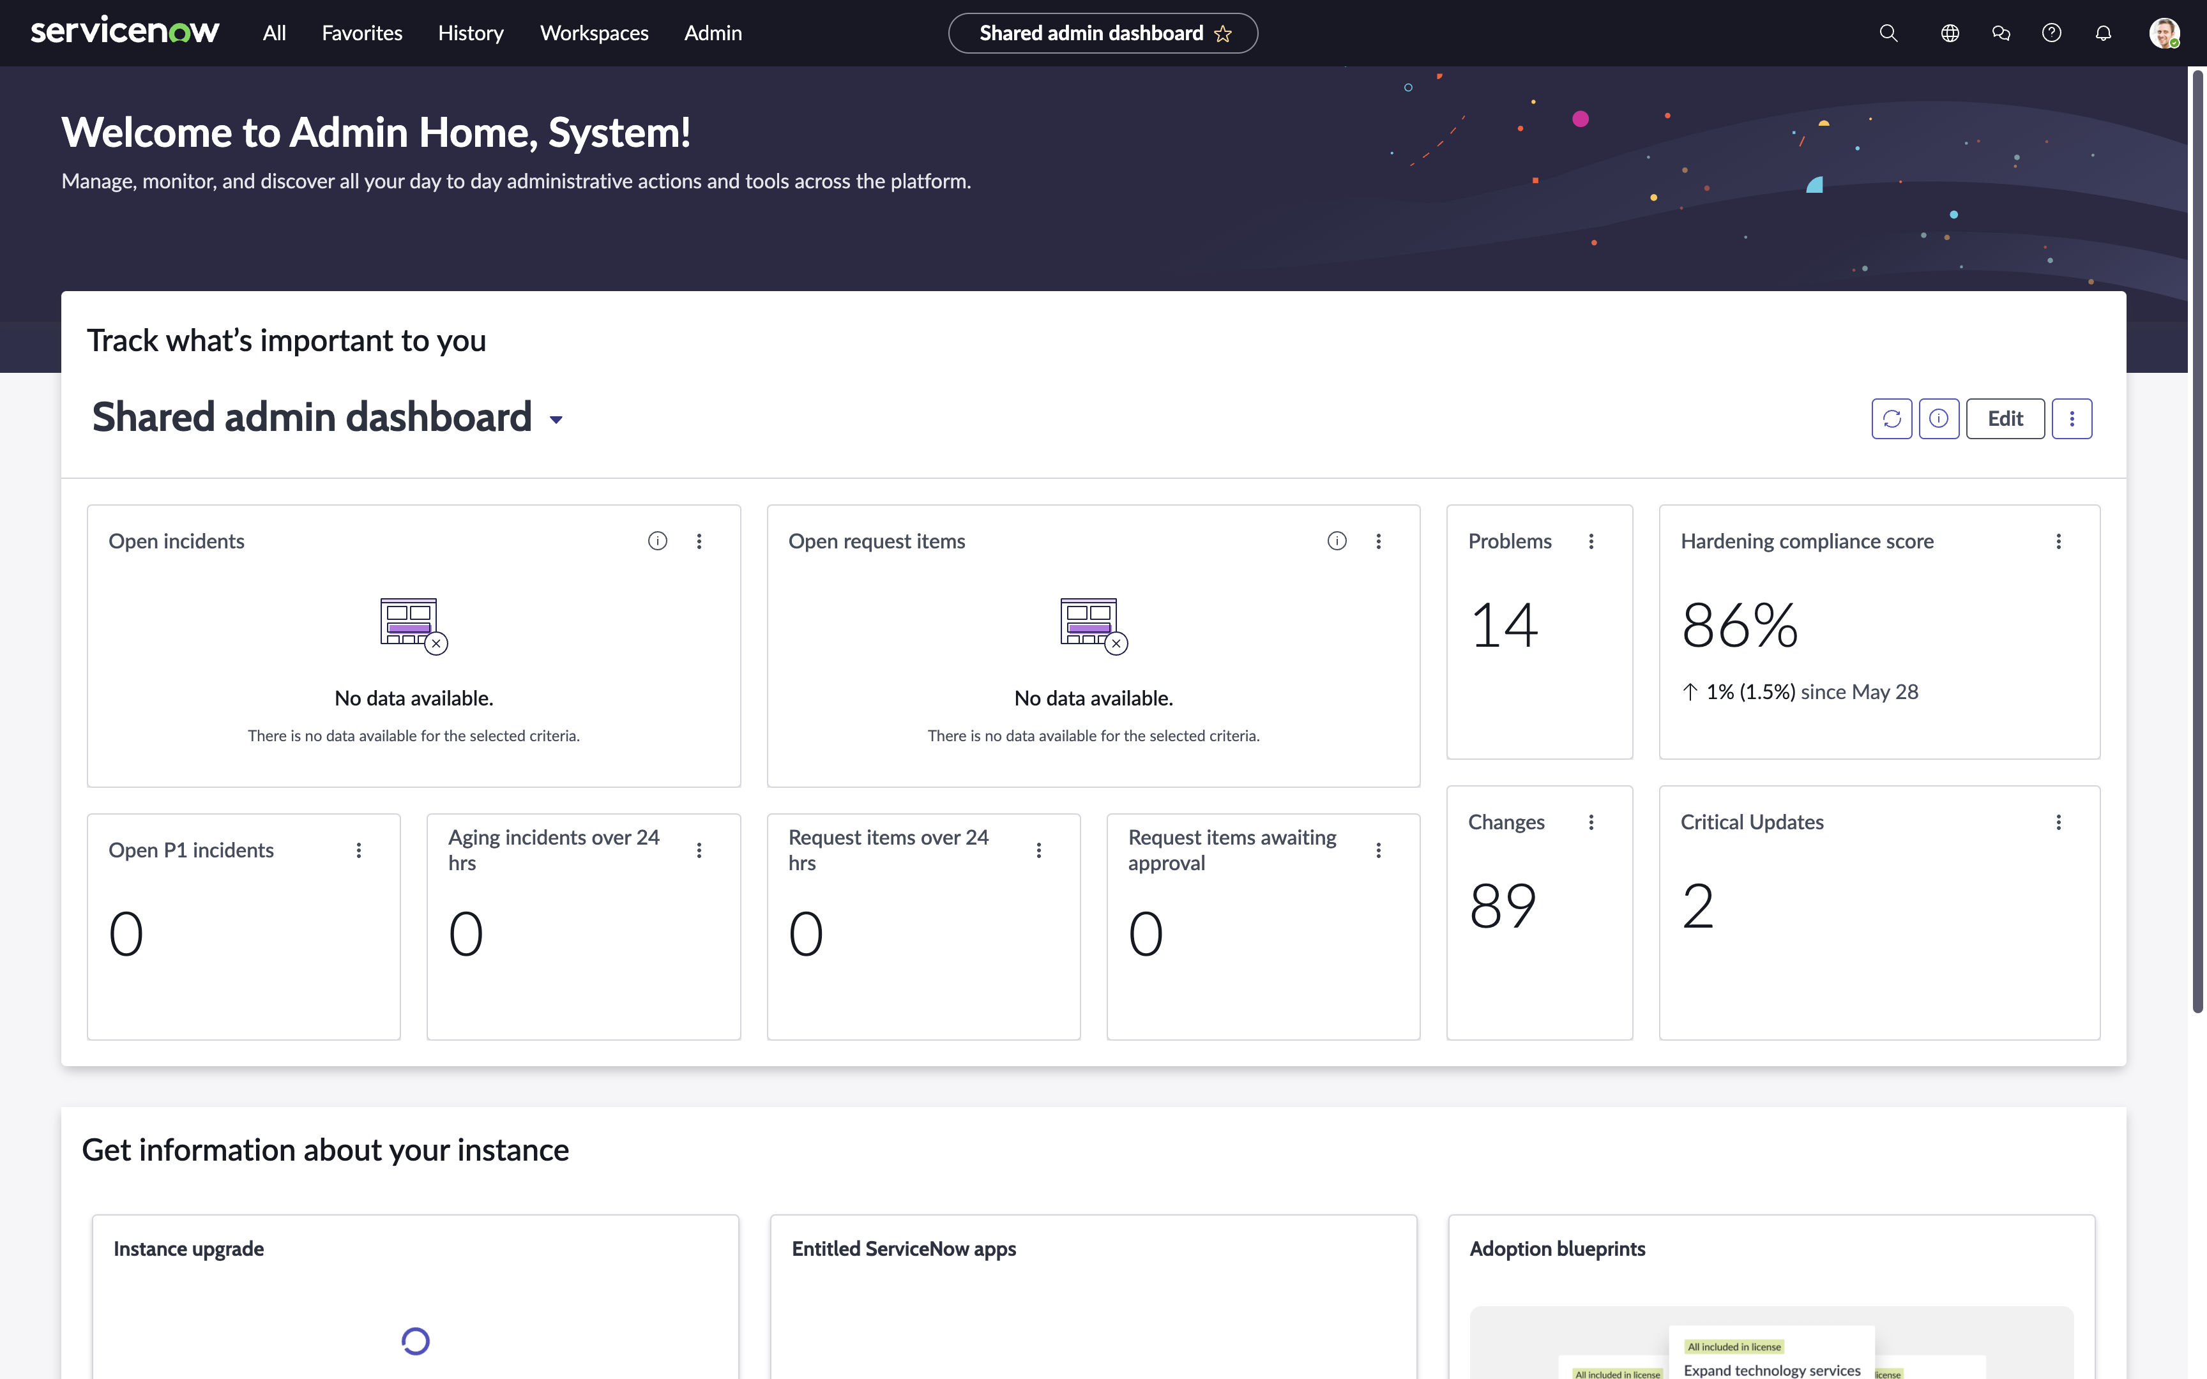

Since the instance you are using is brand new, there will be various “Welcome” and “Get Started” popups throughout – these can be be closed or you can click through them.

Access Creator Studio

1. In the top left click the menu **All**
2. Type **Creator Studio**
3. Click **Creator Studio** below under App Engine

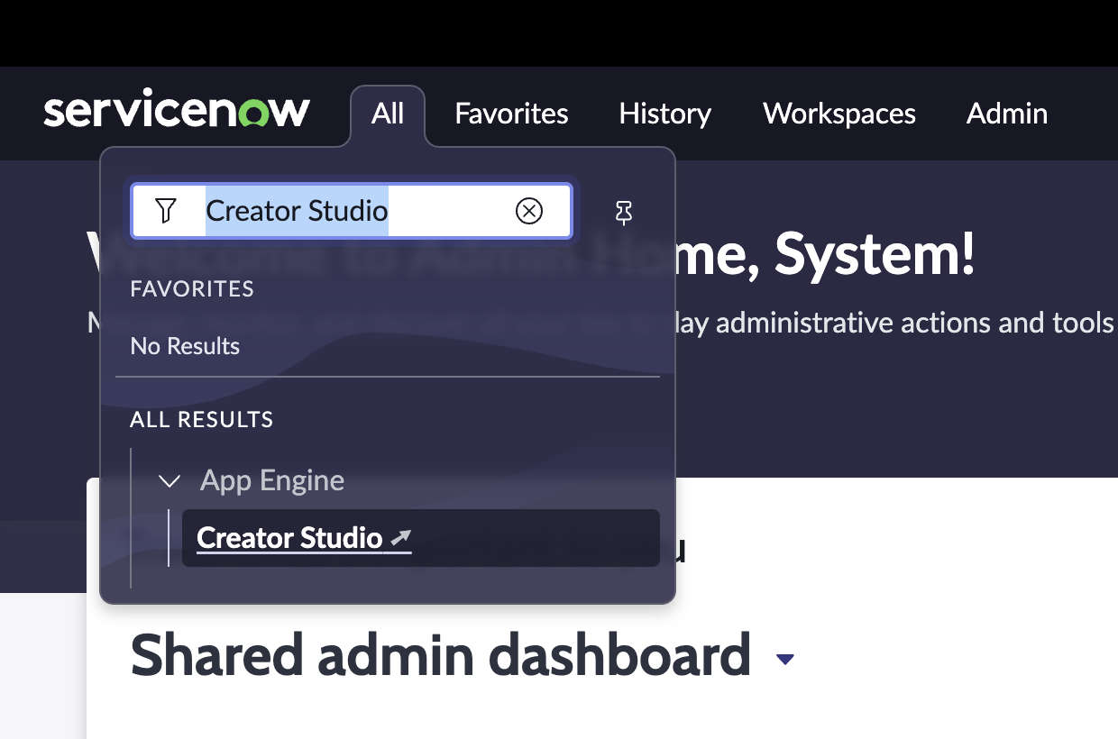

Creator Studio will open in a new tab in your browser. Keep them both open.

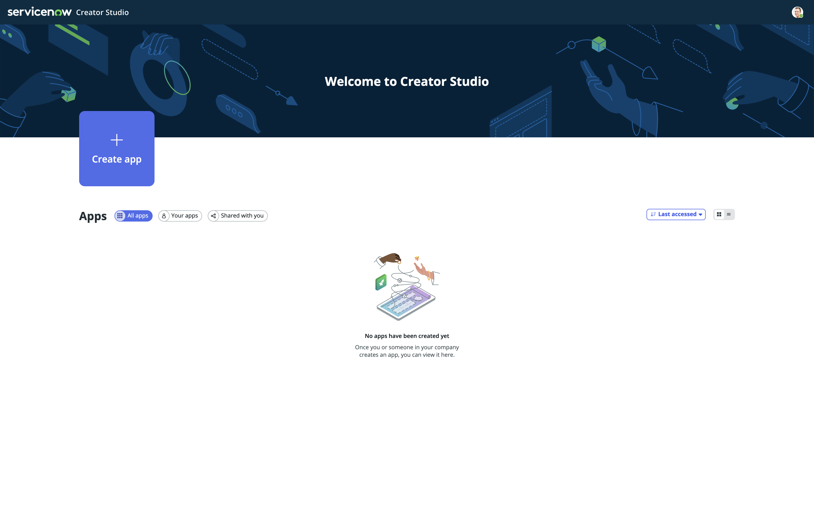

Create your first application in Creator Studio

Let’s get started building an application!

1. Click **Create app** and enter the following:
2. Name: **Gift card request**
3. Description: **Request for both internal and external gift cards for employee recognition**
4. Click on **Create app**

Note: This will create a “scope” in ServiceNow that will house all the artifacts of your application. This also allows for easy deployment from Development to Test and then to Production when that time comes.

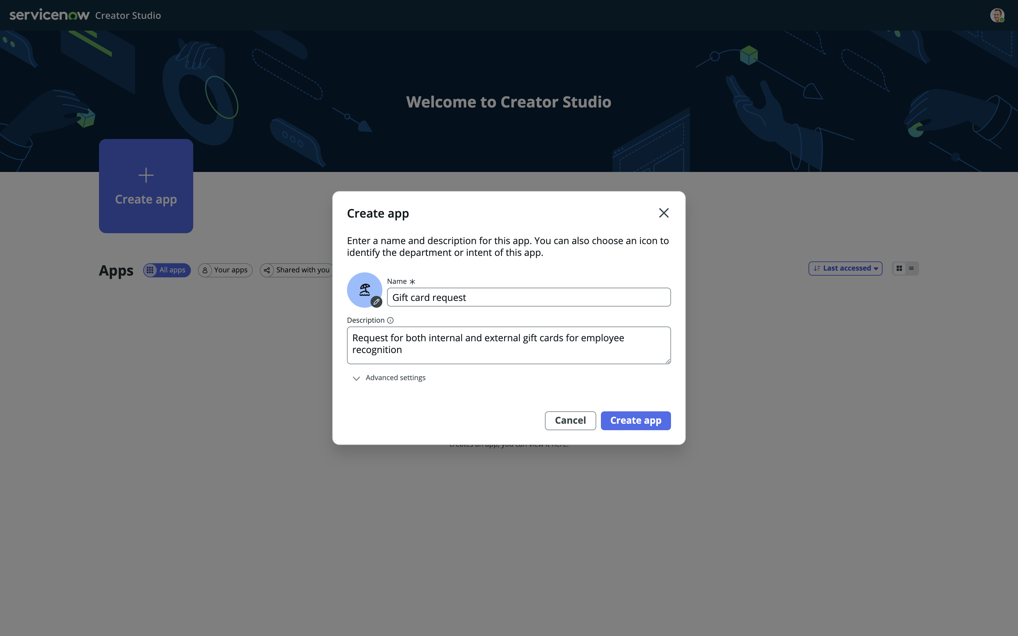

You can enter what ever you want in the Name and Description boxes, it will not have any functional impact on the Lab.

Choose template

Creator Studio currently comes with one teamplate. “Creator Studio Default Template”.

On the left hand you see the available templates, your instance includes two.

On the right hand side, you will se a preview of the choosen template.

1. Click and select **Creator Studio Default Template**
2. Click **Apply this template**

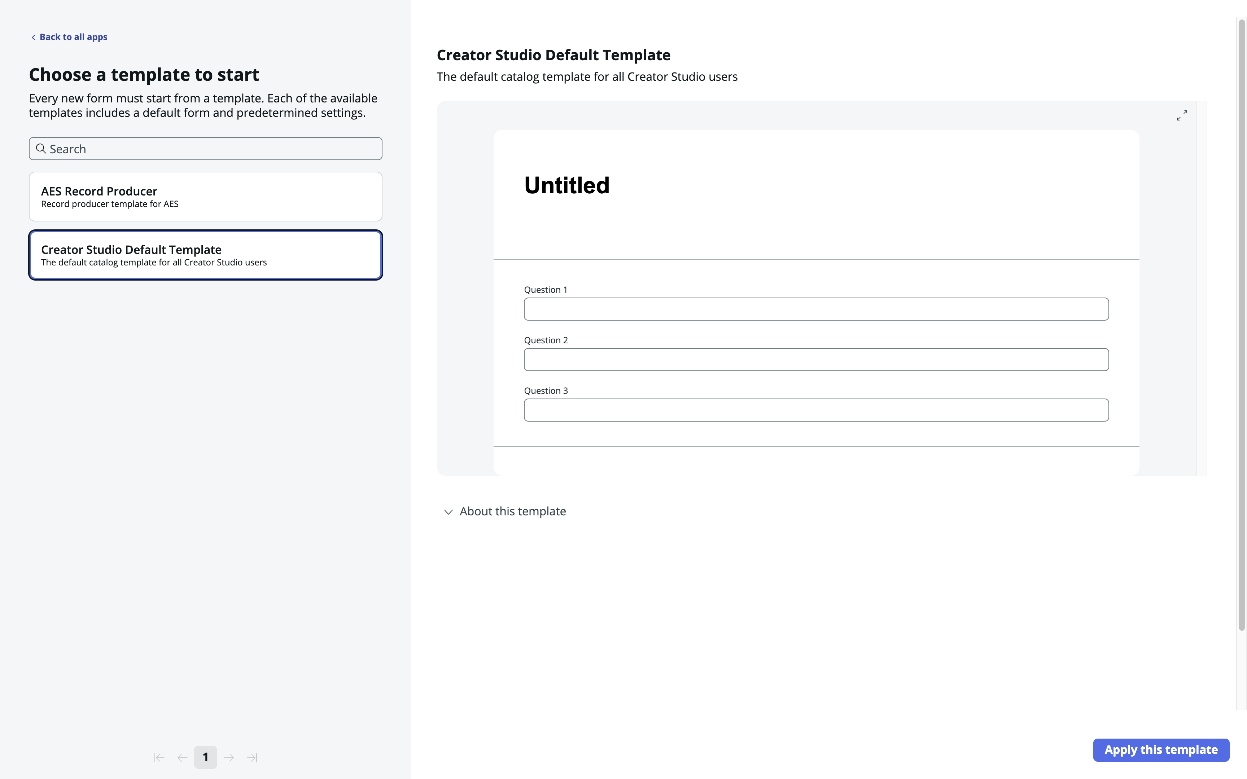

Add your request application to a Service Catalog

You can add the application, or rather, the Catalog Items for your request process, to one or more Service Catalogs and Categories.

For now, we will use “Service Catalog” and the category “Departmental services”

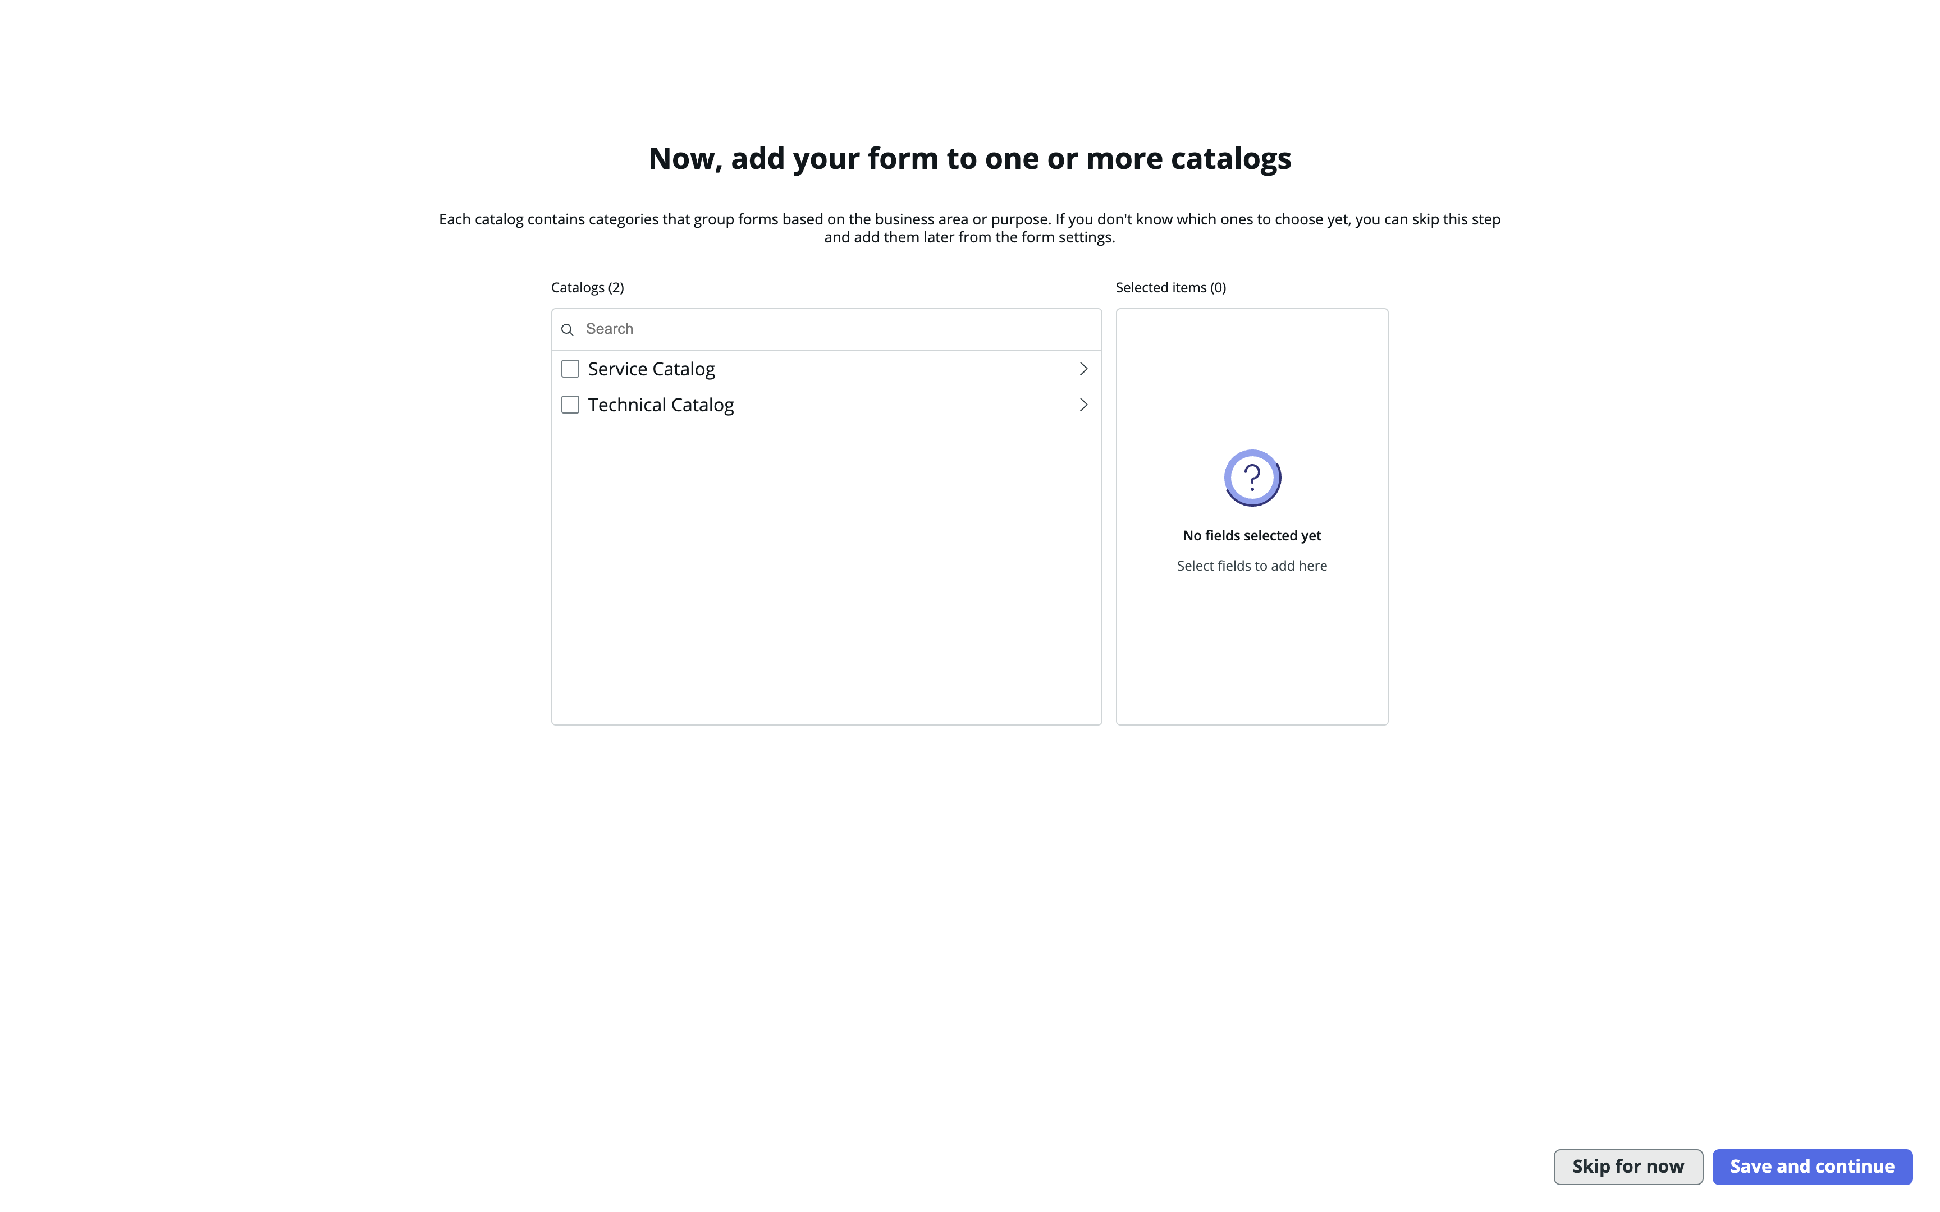

1. Click the arrow next to **Service Catalog** to reveal its categories
2. Check **Departmental Services**
3. Click **Save and continue**

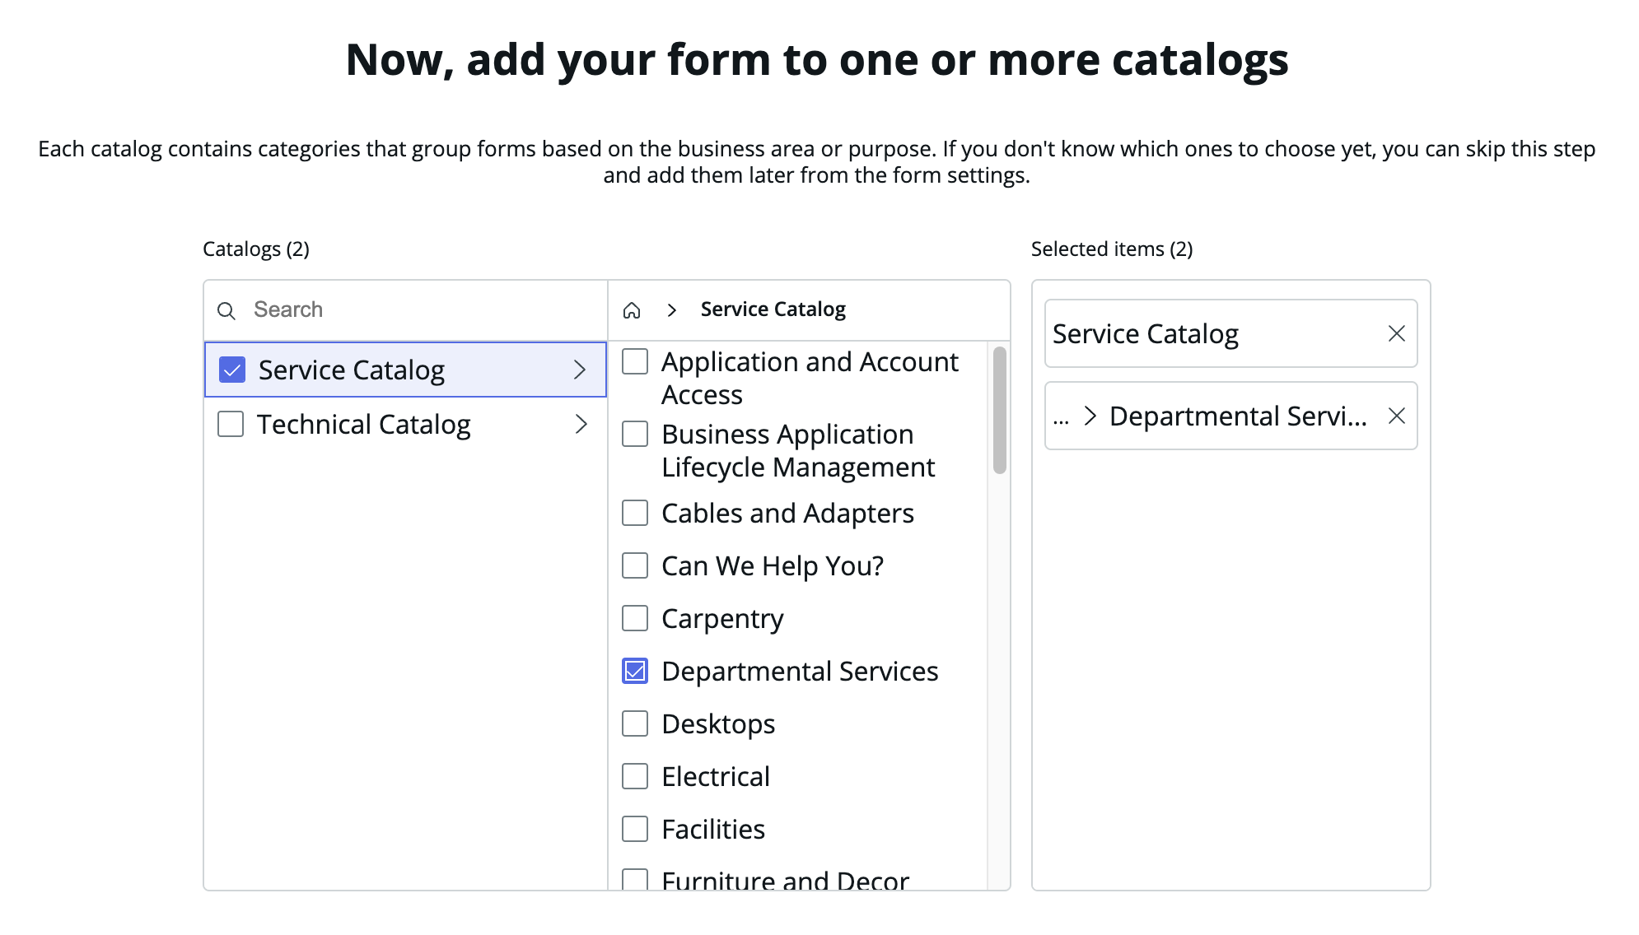

Preview in various experiences

ServiceNow provides various ways to consume its experiences. In this view, you will be able to get a preview of how your request will look in different user interfaces.

You will be able to return to this preview at any time to see your changes.

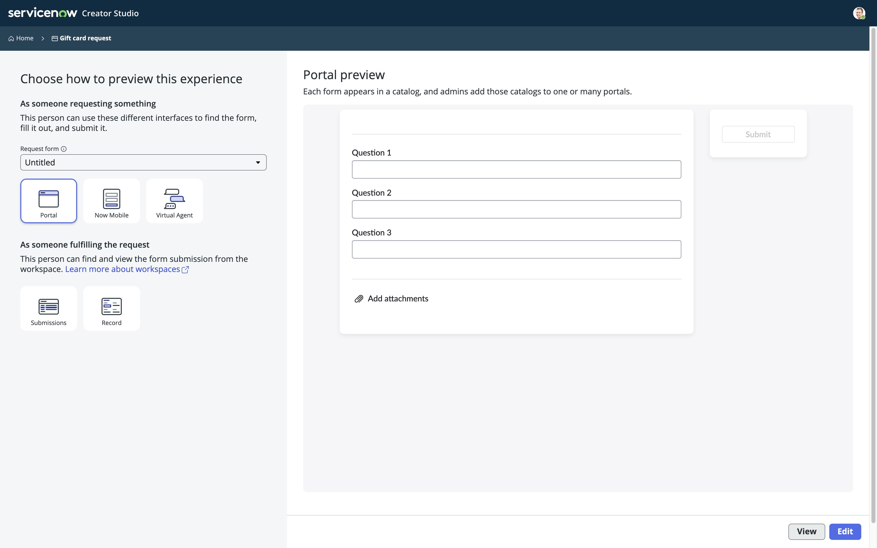

Feel free to explorer these views – you can return here at a later point.

1. Click **Edit** to continue

Section Complete

Congratulations, you have now created an application in ServiceNow and you are ready to edit the application.

Your next step will be to design the Request Form the user will use to Submit their request in your process.

Design your request form

In this section you will design the request form.

Creator Studio – Edit view

This is the edit view of Creator Studio.

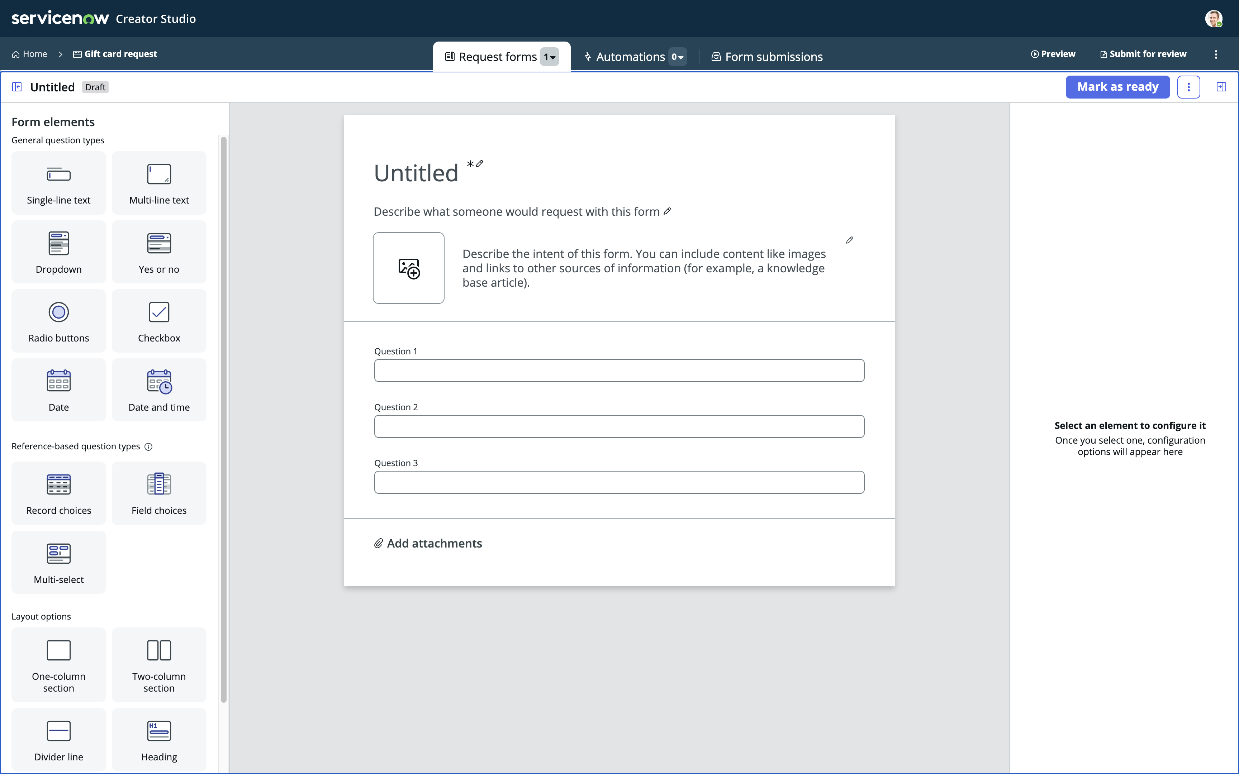

**Form Elements**

**Forms, Automations and Submissions**

**Element Configuration**

**Editing Area**

* **Forms, Automations and Submissions**  
  You can configure three major areas in Creator Studio
  + **Forms** – These will be your catalog items, your record producers. This is what your end user will use to start the process, to submit the request.
  + **Automations** – This is where you can create a Playbook to guide the process user, the fulfiller, on how to fulfill the request of the user.
  + **Form submissions** – This is where you can edit and configure the view the process user will have when they work on a request in the “Request App Workspace”.

On the screen you also see:

* **Form Elements**
  + These are the elements you can drag & drop on to the Editing Area. Each element has different capabilities.
* **Editing Area**
  + You drag and drop Form Elements on to this area to configure Elements you use to capture information from the user.
  + You also name the form (“Untitled” below), give it a description and potentially an image.
* **Element Configuration**
  + Each element has different configuration options, this is where you give the elements their Label, Instructions, Type etc.

Edit your request form

Let’s start by giving the form a Name and a Description. This information will be used to match what the user searches for in the Service Portal.

1. Click on **Untitled** and change it to **Gift card request**
2. Click on the line below and change it to **Request gift cards for employee recognition**.
3. Now click on the description right of the image place holder, notice you get a rirch text editor here. Change the content to:  
   **Looking for a great way to recognize your colleagues? Use this form to request a gift card to our internal company store or to a third party store of your choice! Internal gift cards under $50 will be automatically approved, all others will go through finance approval.**
4. **Optional:** You can click the image place holder and upload an image if you have one.

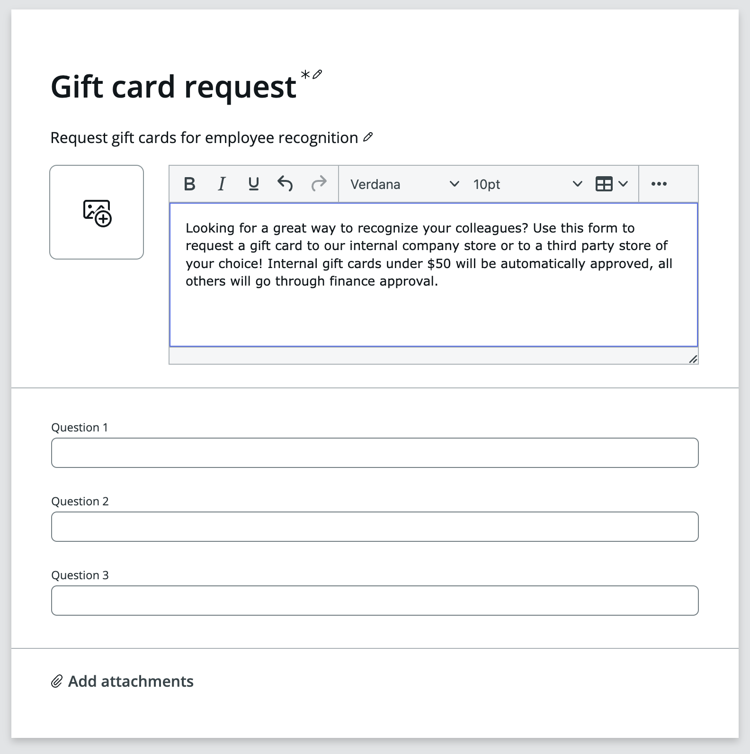

Our next step will be to define the options for the user, and replace the placeholder questions on the bottom half.

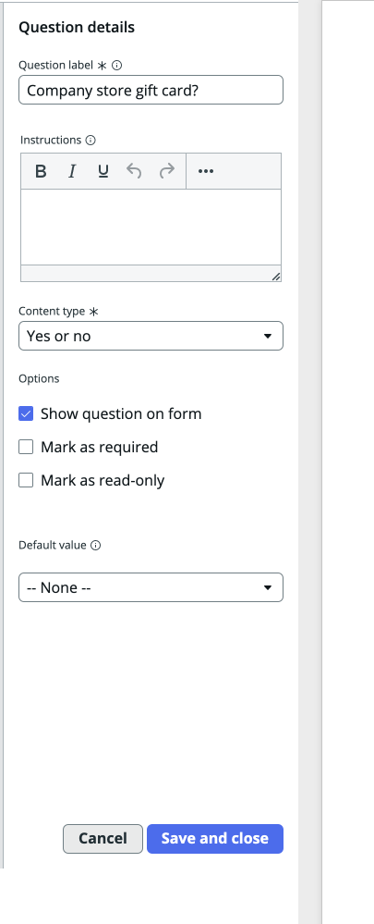Edit the form

1. Click to edit **Question 1** and on the right hand side change the following details  
   Question label: **Company store gift card?**Content type: **Yes or no**  
   Click **Save and close**
2. Click to edit **Question 2** and just like above, change the following details  
   Question label: **Amount**Click **Save and close**
3. 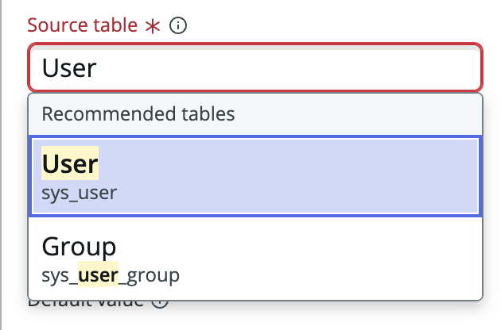Click to edit **Question 3**Question label: **Recipient**  
   Content type: **Record Choices**Source table: **User** [sys_user]  
   Click **Save and close**

**Note:** for this *(20)* question, we choose to reference a ServiceNow table.

This gives us the option to dynamically populate a popup with data available   
in the platform.

1. 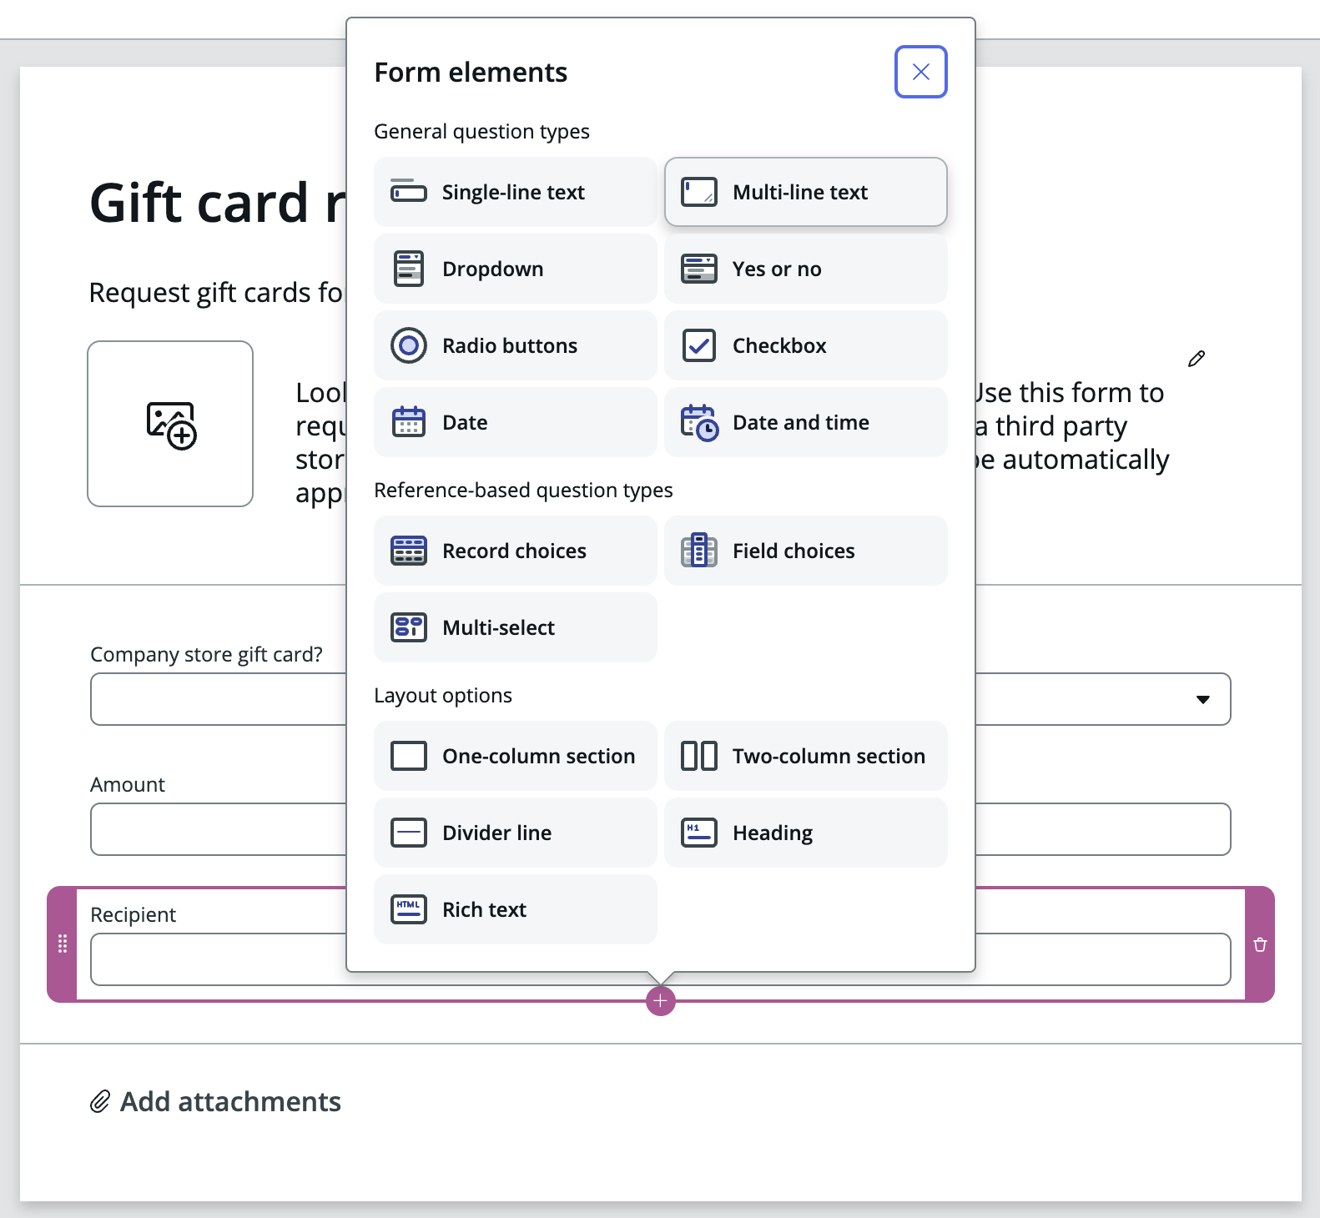Add another form element to capture the **Justification.**With the bottom form element *Recipient* selected – click the **Plus +**  that shows up below the form element and choose to add a   
   **Multi-line text** element.  
     
   Alternatively, drag and drop a a **Multi-line text** element from the Form elements section on the left on to the Edit area.  
     
   Give the element a label: **Justification.**Click **Save and close**

Section Complete

Congratulations, you have now created the form for your application.

Your next step will be to design the processes that takes care of the approval from the requesters manager and the appropriave approval group.

Create a Playbook for Automation

In this section we will create a playbook for automation and design the approval process.

We will create a playbook that runs when the user request a gift card from an external store (when user select NO for the “Company store gift card?” question you created earlier.

1. Click **Automations** on the top tab section.
2. Click **Create** **a new playbook** and name it **Approve internal gift cards**
3. In the Create playbook popup, scroll down to **Filter conditions** and click **+ Add conditions**.  
   In the **Select field** popup for the filter conditions, click and scroll to the bottom to **Questions.**You can then either type, next to the magnifying glass, what you’re looking for (Hint: gift card) or scroll down to it on the right hand side.  
   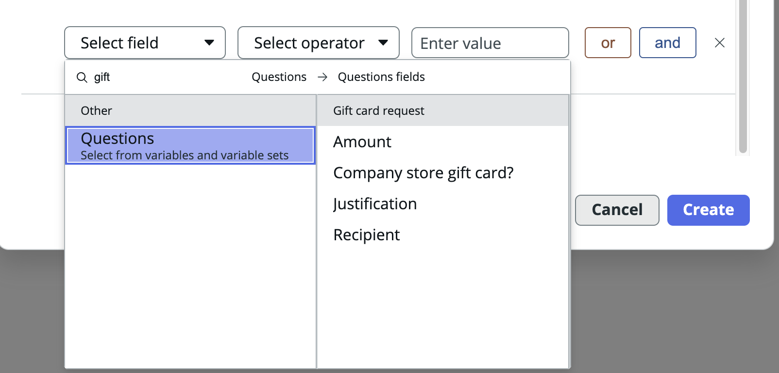  
   Select **Company store gift card**
4. Next select **is** as a selector in the middle popup and **Yes** in the last *(Enter value)*.  
   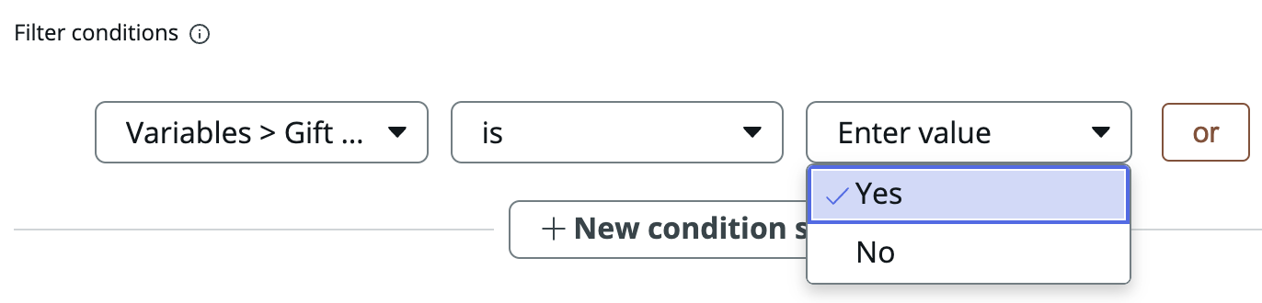  
   Note: Due to a UI-glitch in the Lab instances, you will not see that you selected “Yes” in the last poup – it will show “Enter value” reglardless of what you choose. Don’t worry, your selection is still made.  
   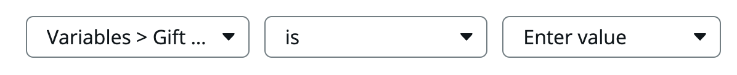
5. Click **Create**!

You have now created a Playbook that triggers when it’s needed. Our next step is to define the actions we want. The **Fulfillment steps**.

We will now create steps to request approval from the requesters manager

The middle box **Fulfillment steps** will contain your logics.

Since Creator Studio is all about simplicity, the user is limited to one fulfillment step. More advanced playbooks can be built using **Workflow Studio** but, that’s for another lab.

**Note:** When you open a popup in this view to add or configure steps, your work is saved as soon as you click **Save and close** in the popups shown.

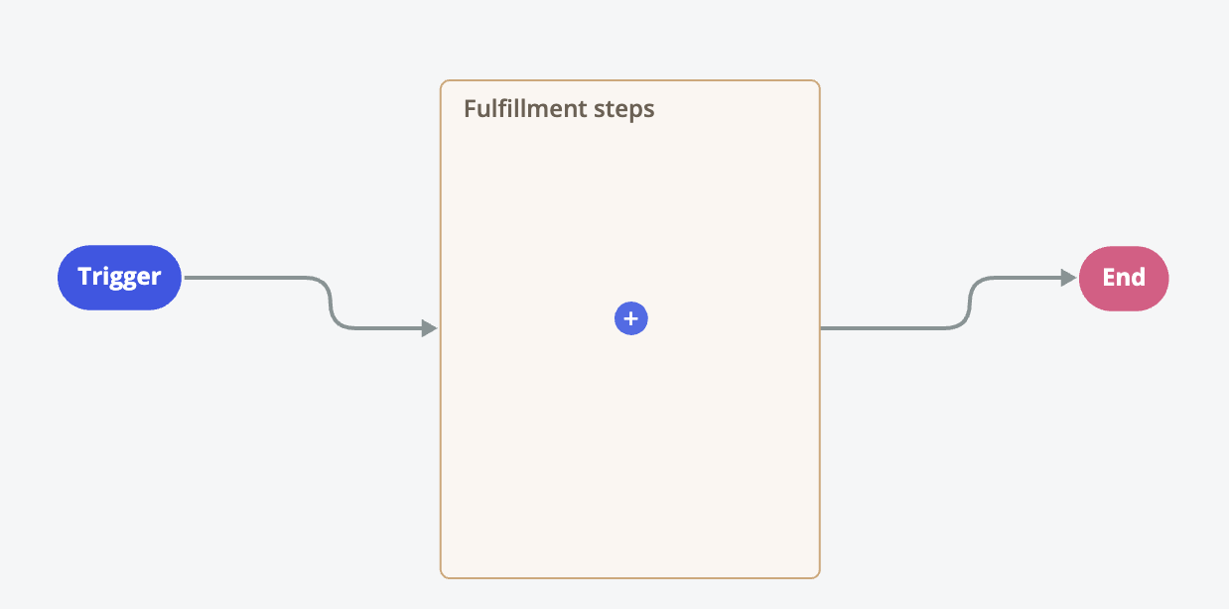

1. 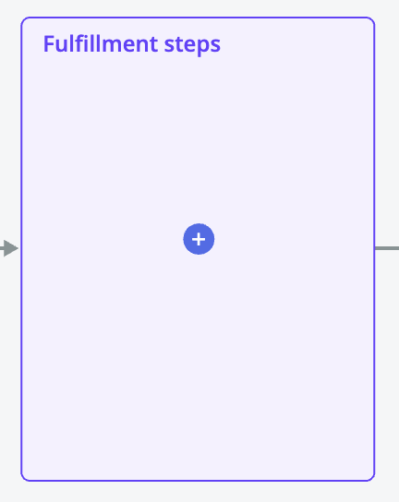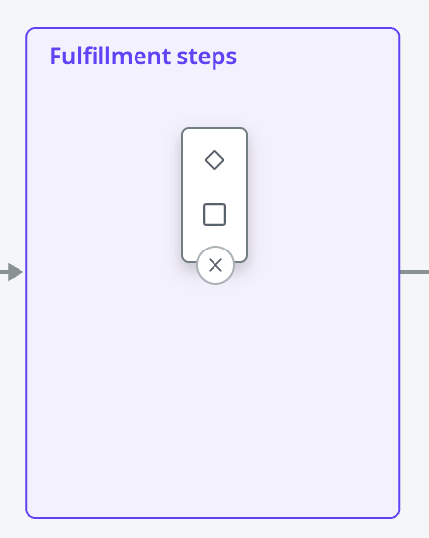Click the **Blue +** to add a new step.  
   You then get two options.  
   The top **Romb** symbol creates a **Decision activity** (if/then)  
   The bottom **Square** symbol adds an activity. Click the bottom **Square** to add an activity.
2. In the popup shown, choose to add a **Request approval** activity.  
   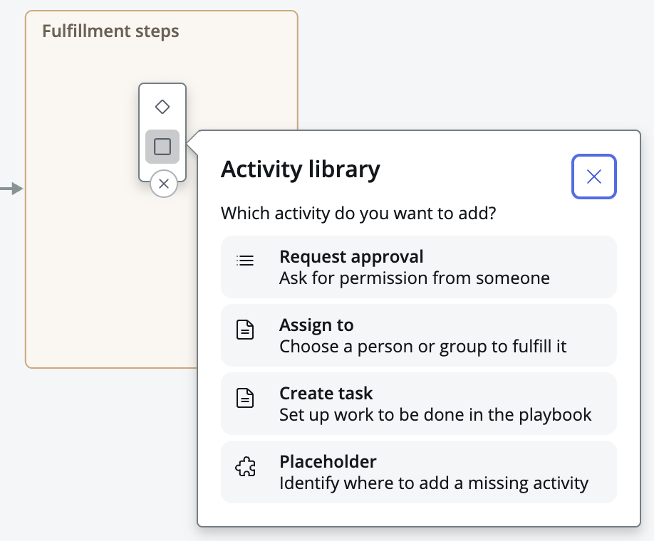
3. 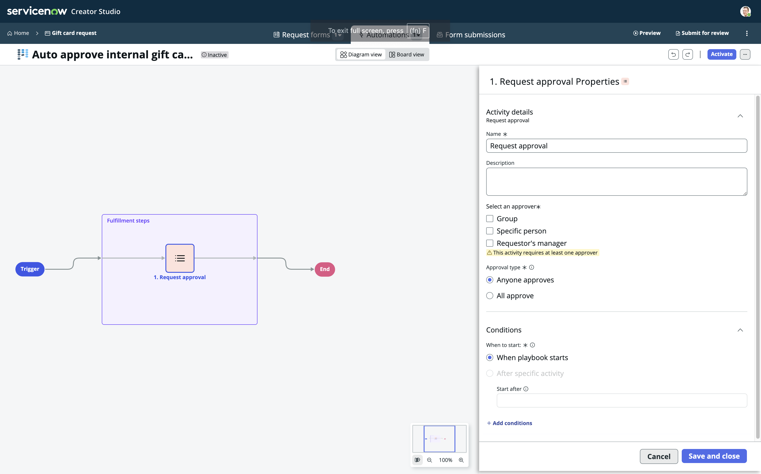In the properties for the **Request approval** activity, update the Name to **Request manager approval** and select the checkbox for **Requestor’s manager**.  
   Click **Save and close.**
4. In the top right of your screen, click **Activate** to make the new Playbook active for all new requests.  
   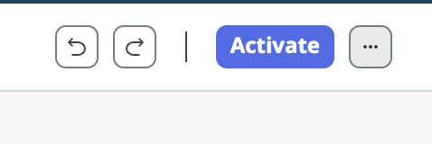

Section Complete

Congratulations, you have now created playbook automation for your request.

Next, let’s review the workspace used to fulfill the requests.

Review the “Forms submissions” section

For applications created in Creator Studio, there is a common workspace called “Request app workspace”. Process users, fulfillers, use this workspace to work on the tasks created in the various applications created in Creator Studio. Access to a certain process is provided by roles created by Creator Studio.

The last part to review and configure is the section for your process in the common Request app workspace.

1. Click **Form submissions** in the top center of Creator Studio.

This view allows you to configure the view your process users will use to work on individual records.

The left hand column provides a few pre-configured list filters for the records and table created for your process. Clicking “Add filtered list” you can add more options for your users.

The center previews the list view and on the right hand side you configure both the selected list from the left column and the shown table columns previewed in the center view.

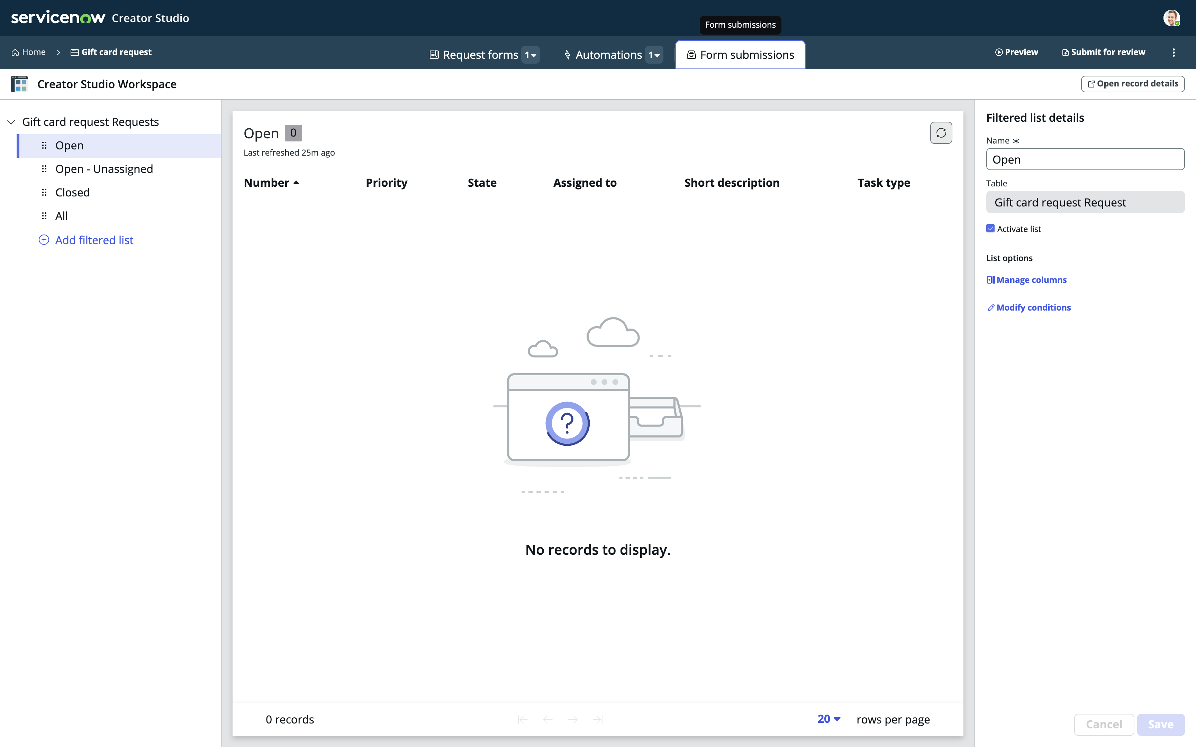

We will not make any changes to this view in this lab.

Section Complete

Congratulations, you have now reviewed the Workspace for your process.

Now, let’s give it a quick try.

Test your application

Publish the Catalog Item

To test the application and process, we need to view the Catalog Item we created and we will need to test the Workspace.

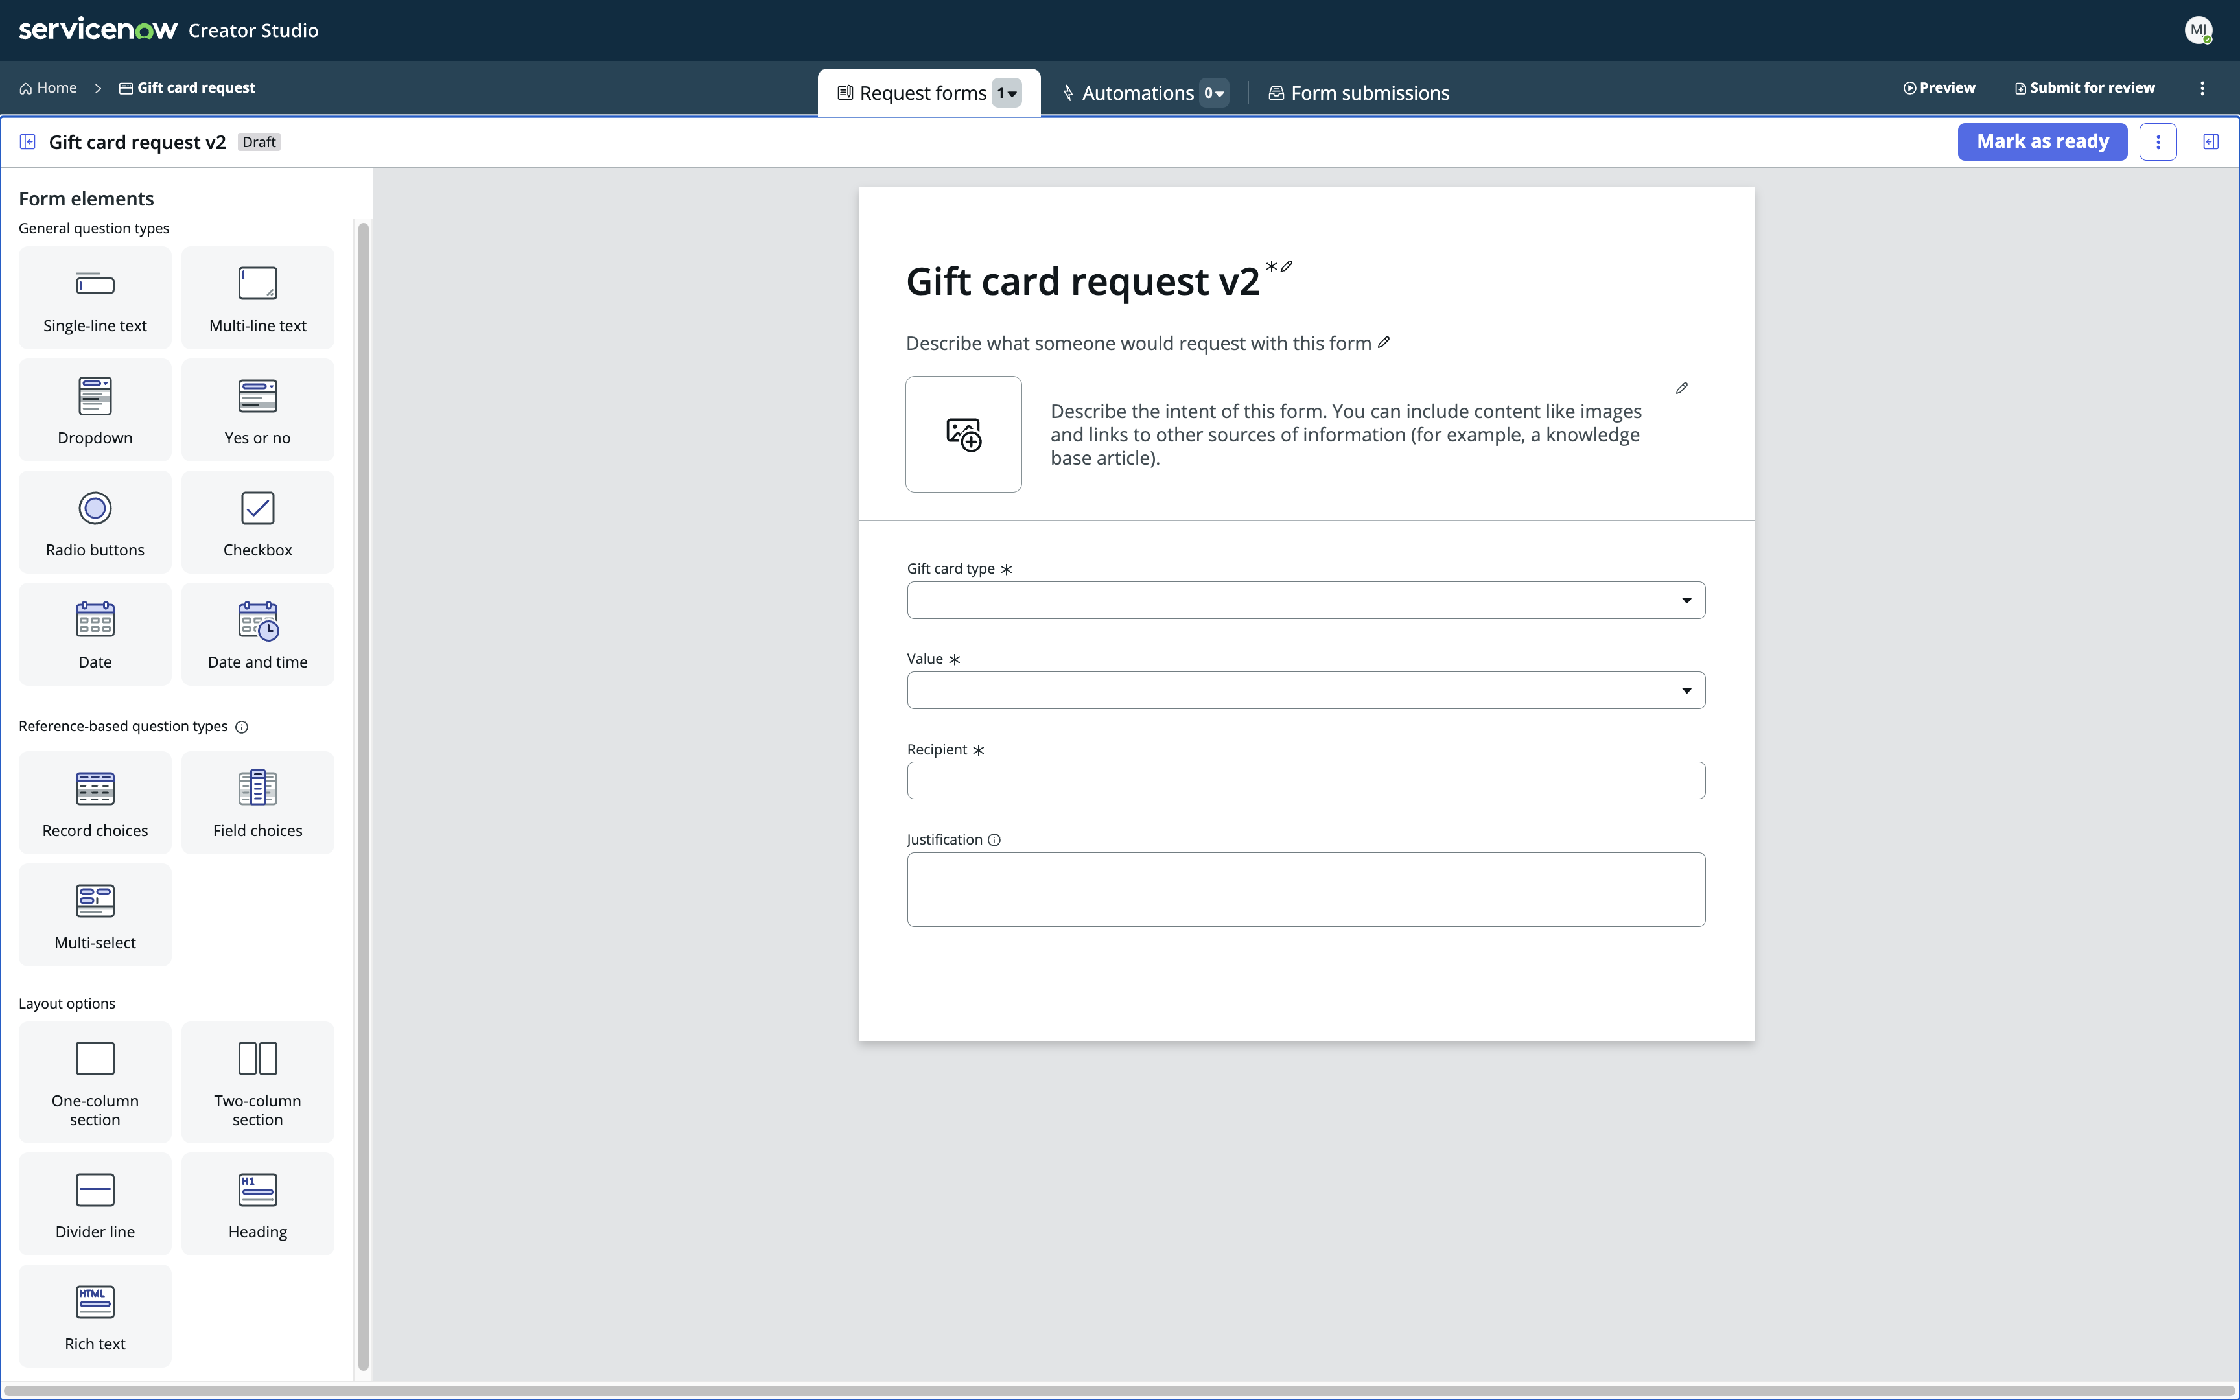

1. Go back to the **Request forms** view and click the **Mark as ready** button top right.

Note: This action will “publish” your Catalog Item in the development instance you are working in. Doing so will enable us to test it!

We will now **impersonate** another user, remember we have built this using an admin persona.

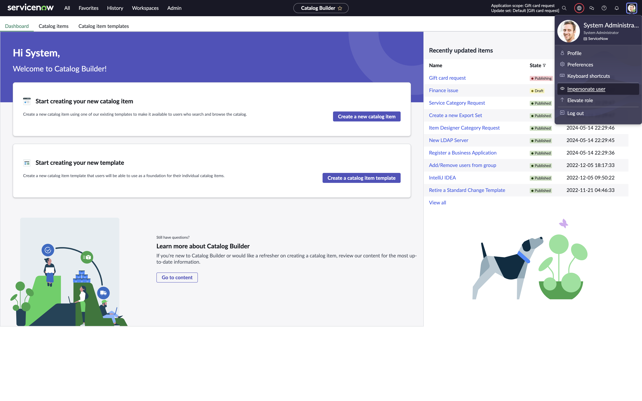

1. Click the user profile top right of the screen and choose **Impersonate user.**
2. In the **Impersonate user** box, type and choose to impersonate the user   
   **Billie Cowley** – when selected, click the **Impersonate user** button.  
   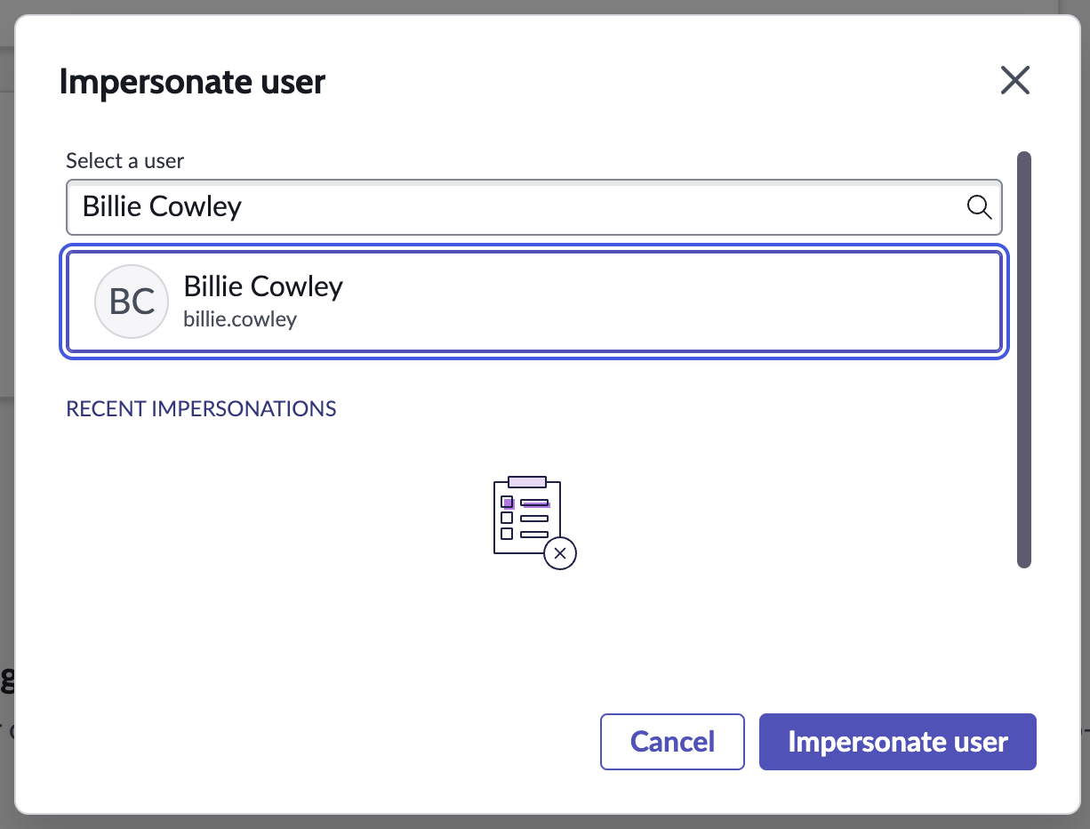

Note: Everything you do from now on will be “as” Billie Cowley.

1. 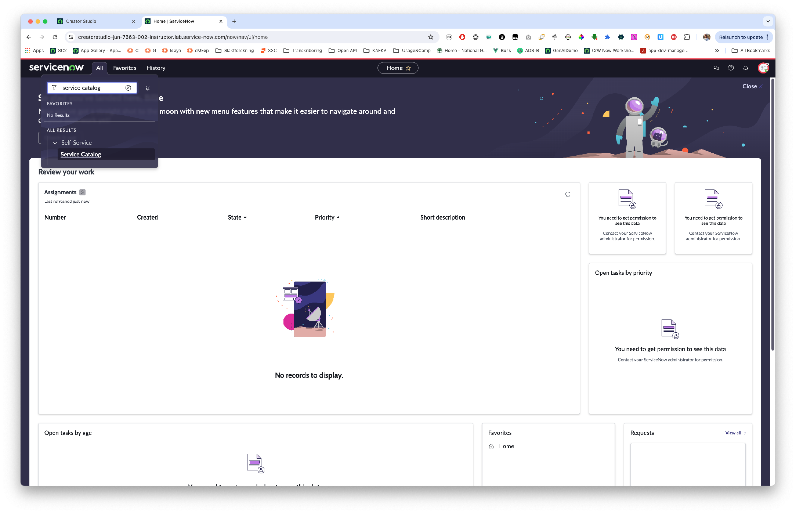Now, as Billie Cowley – In the **All** menu, type and click to open **Service Catalog** (the quickest way for us to find our catalog item and test it “live”).
2. Once in the service catalog, search for **Gift card request** in the top right part of the service catalog view. Press **Enter** to search.  
   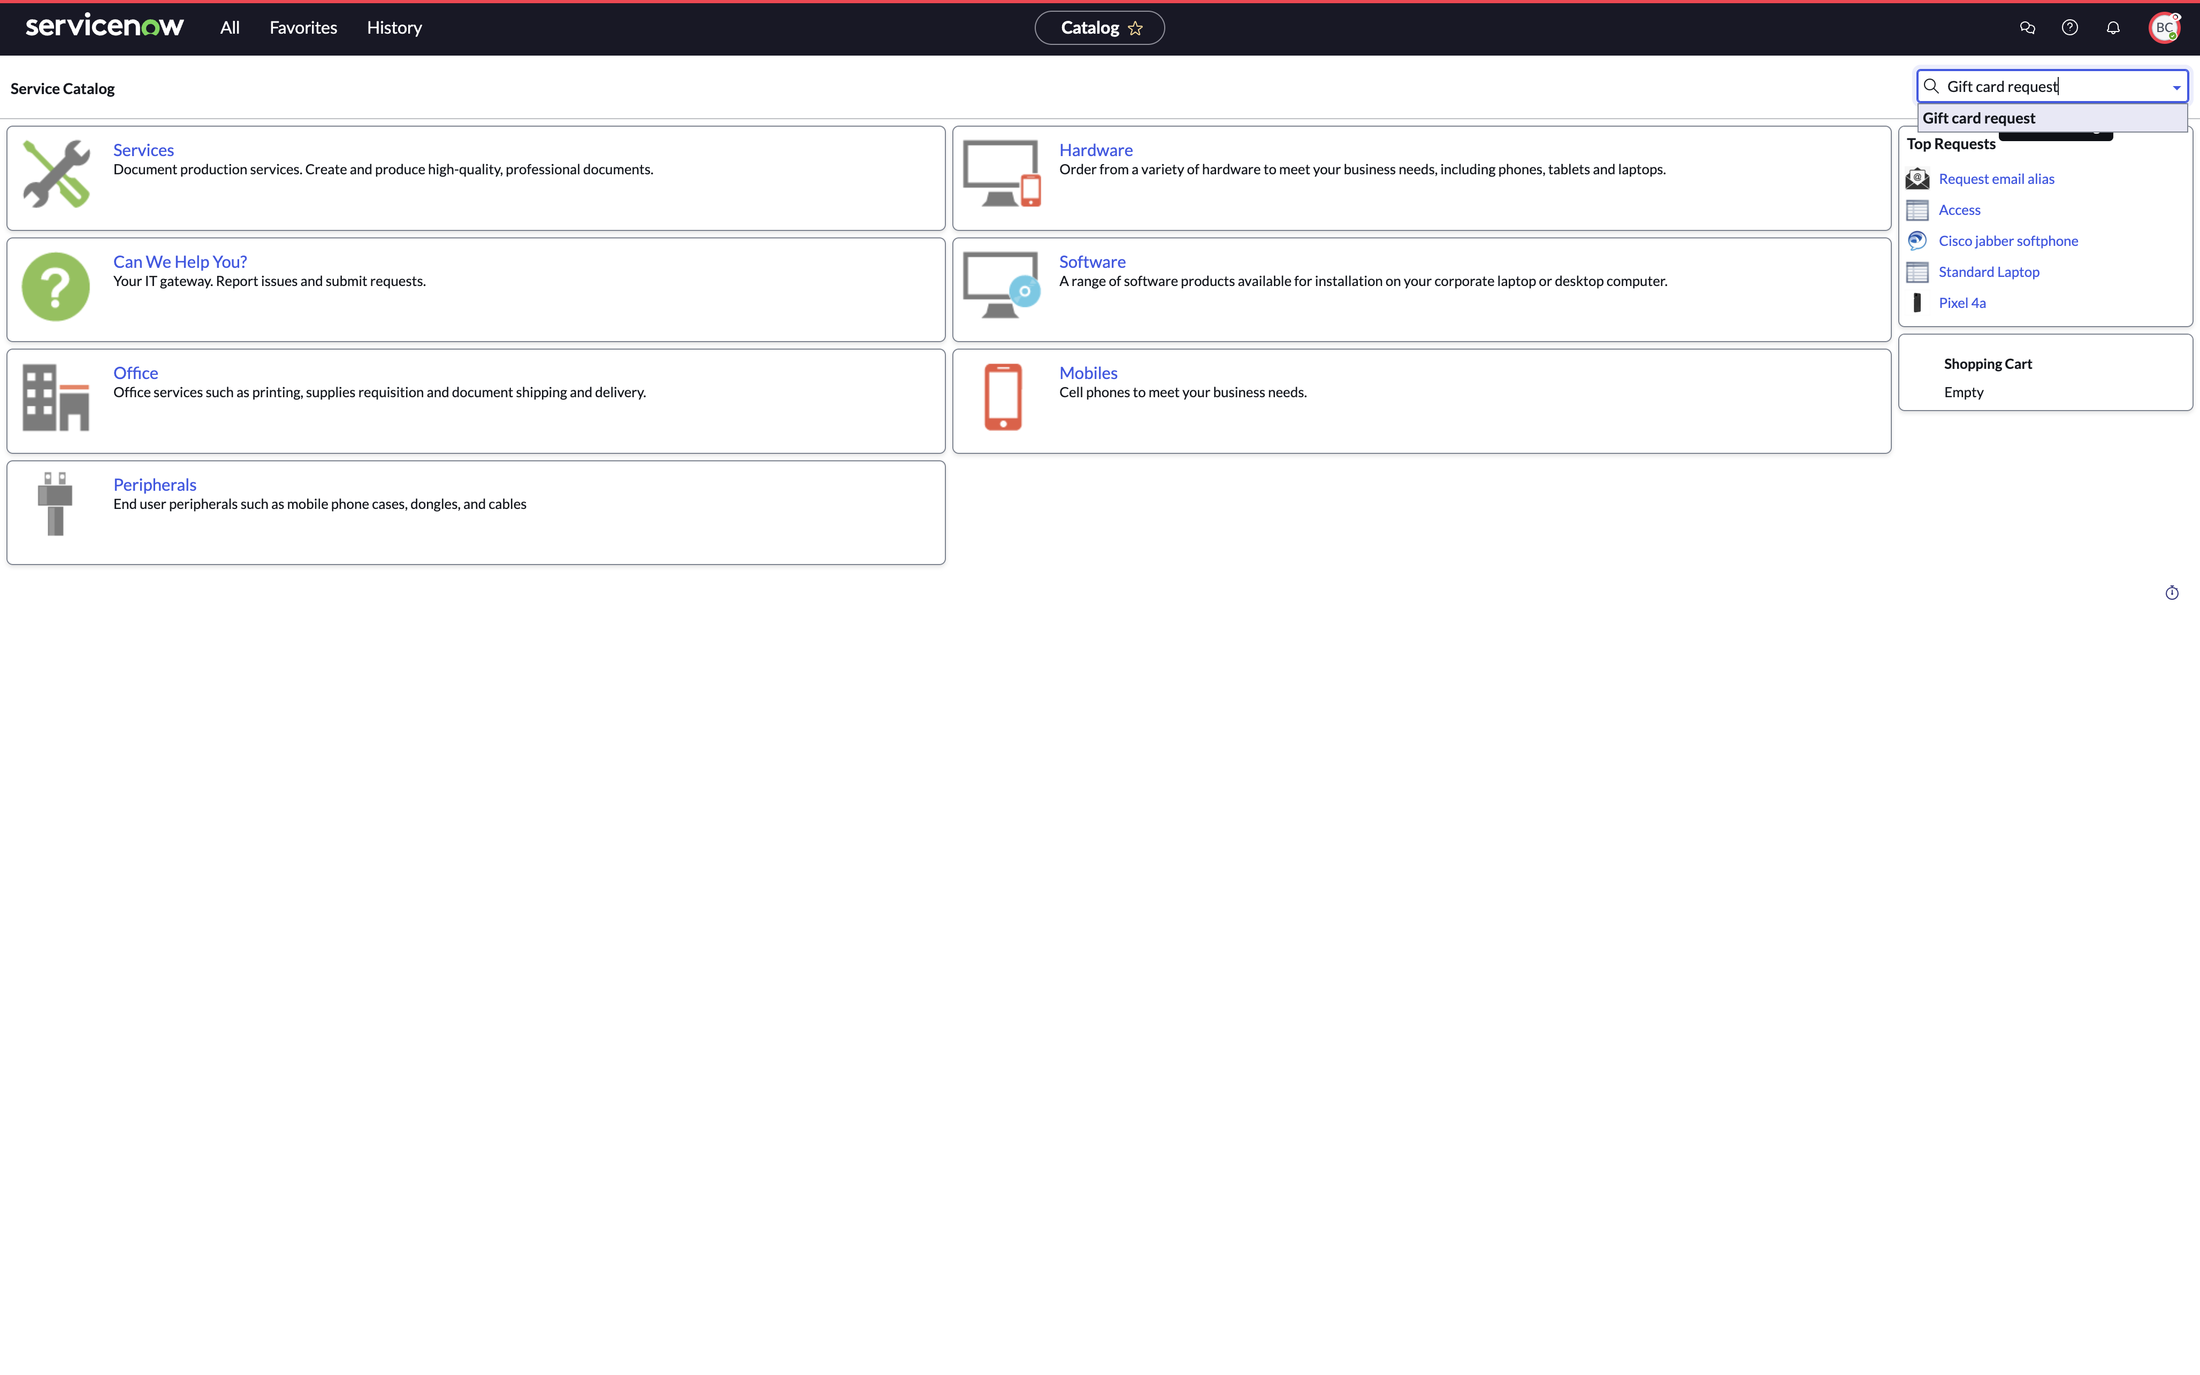
3. Click the **Gift card request** in the search result.  
   This will give you the ability to submit a test request, as Billie Cowley.
4. Fill out the form:  
   * Company store gift card: **Yes**  
   * Amount: **100**\* Recipient: **Joe Employee**  
   * Justification: **Well done job!**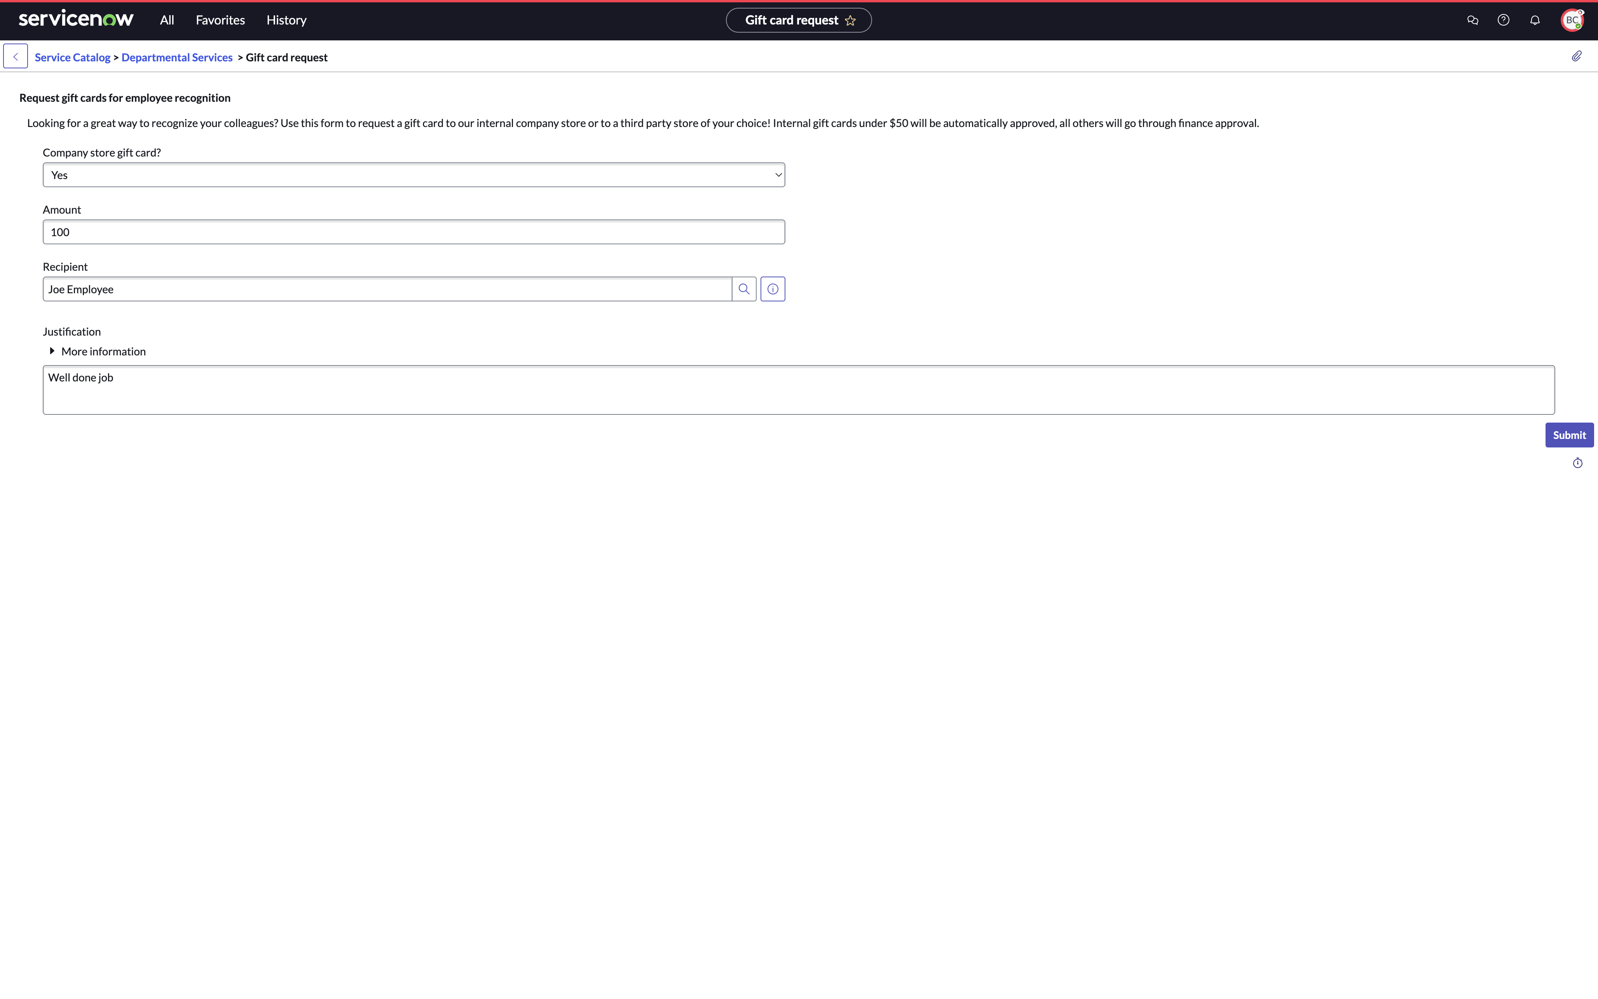
5. Click **Submit**
6. In the top right user menu, click **BC** (for Billie Cowley) and choose **End impersonation** to go back to your admin persona.

Note: You have now submitted a request as **Billie Cowley**. Billie has a manager, Crystal. Back as the developer/admin persona we will try out the workspace for Creator Studio requests.

Test the “Request app workspace”

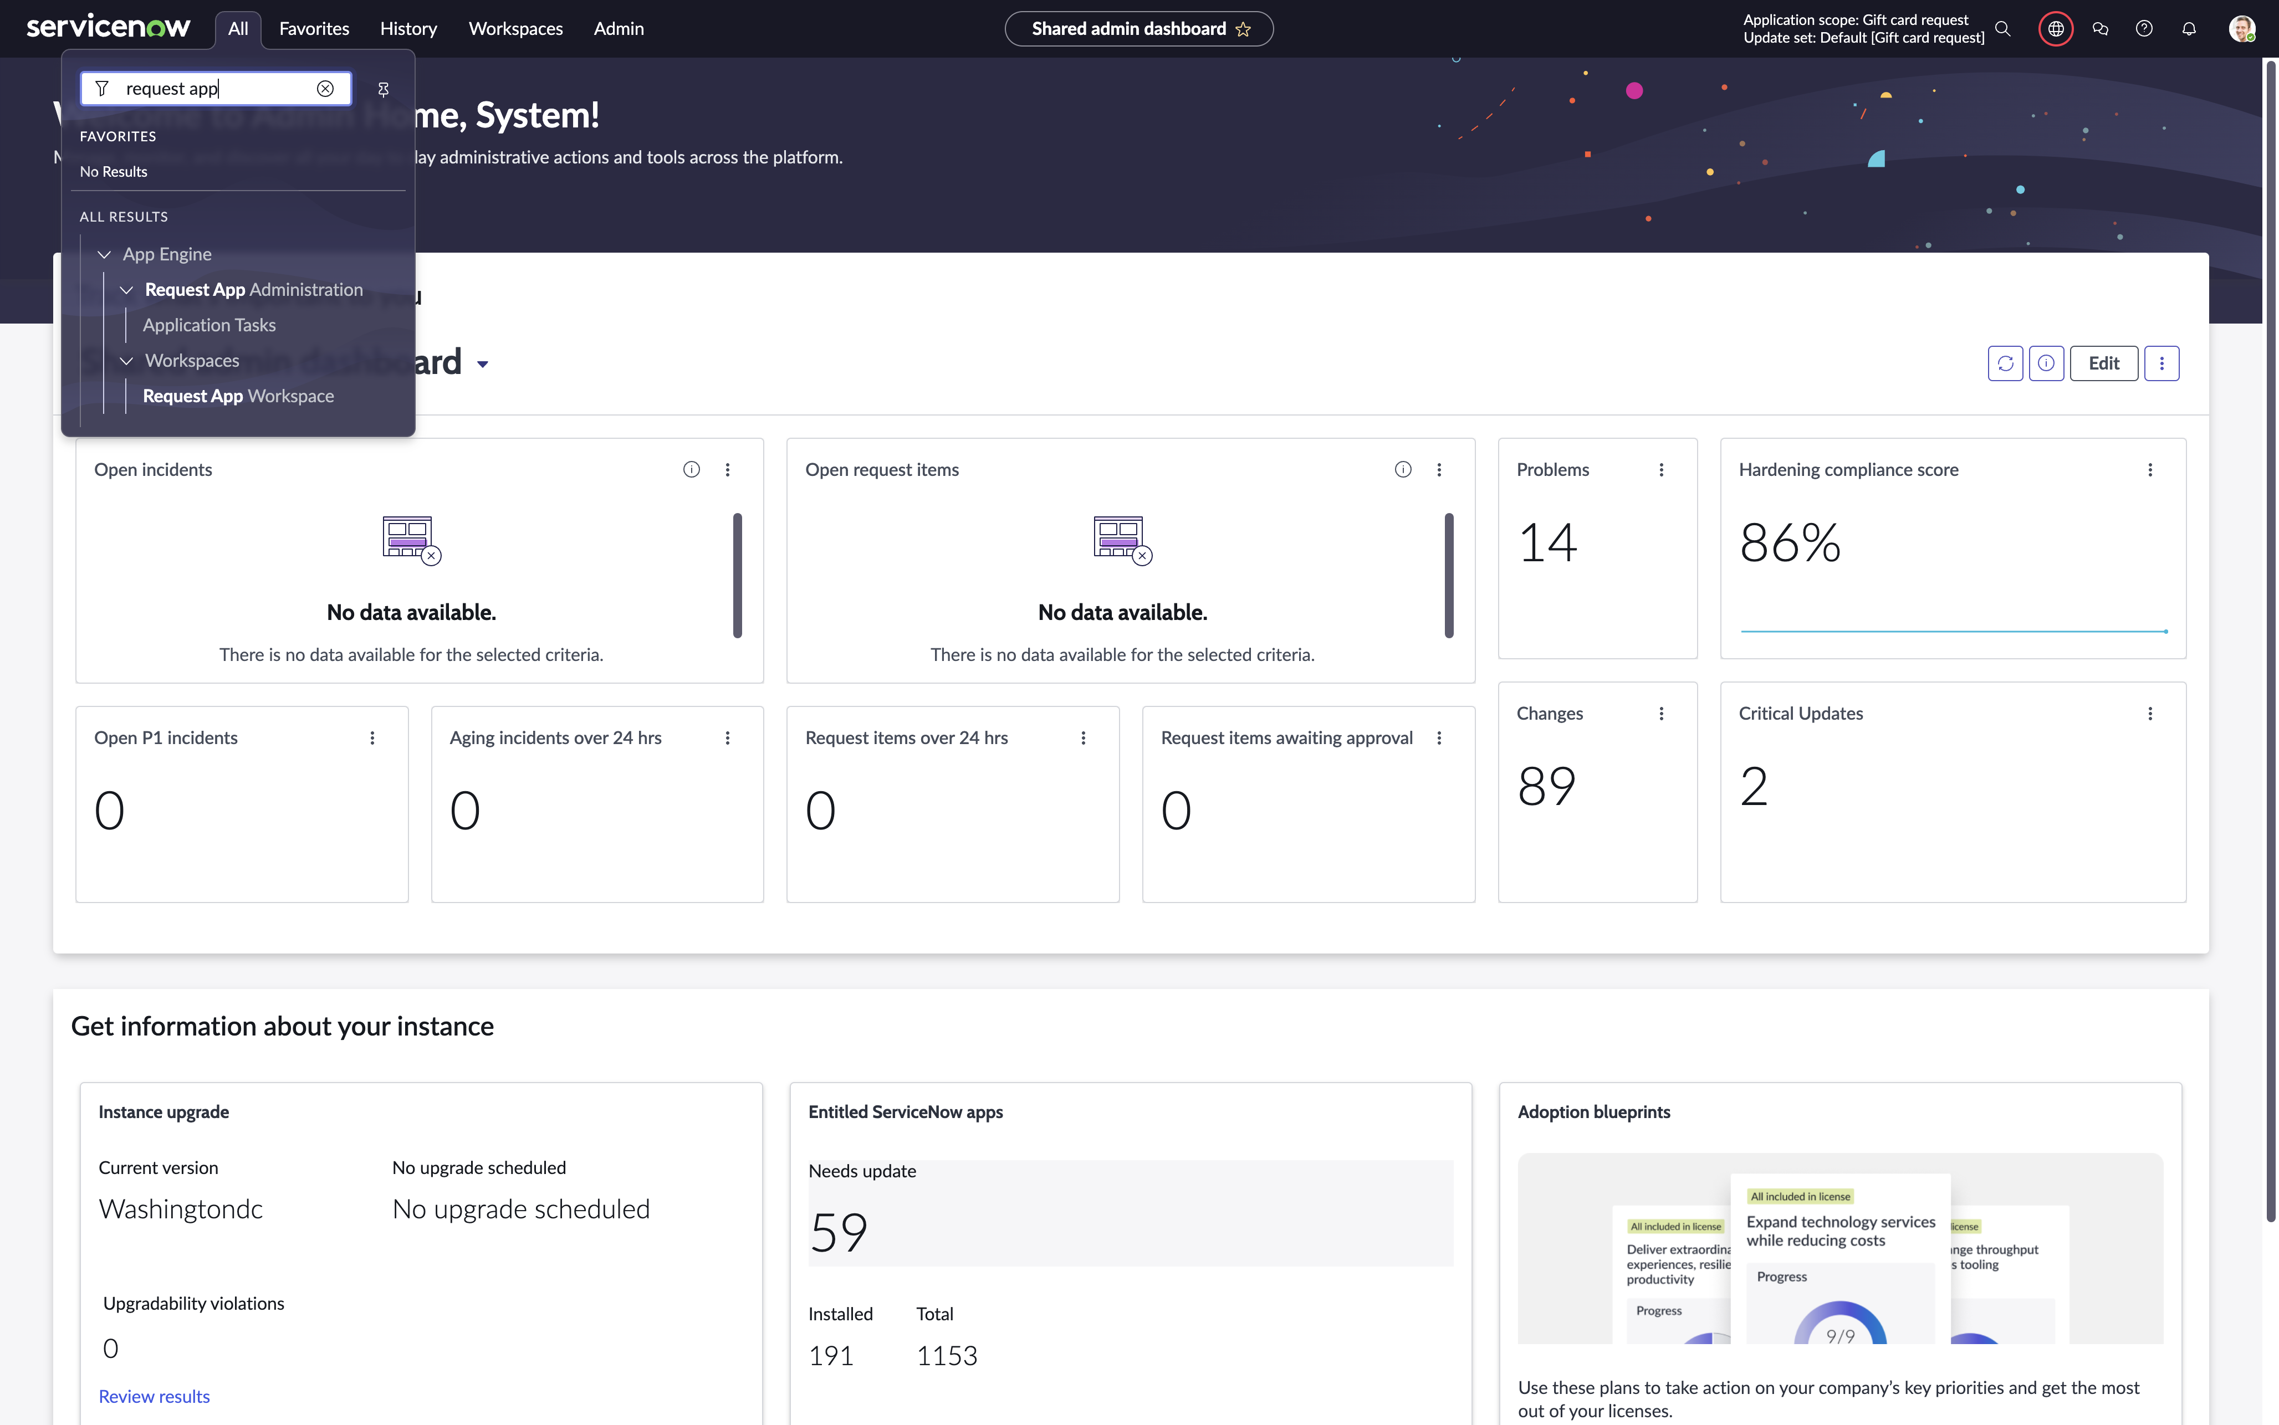Now back as admin

1. In the **All** menu, type and click **Request app workspace**

The workspace opens up.

This workspace is a common workspace for all applications built using **Creator Studio**. Access to individual processes built is governed by the roles defined when the application and workflows are created in **Creator Studio.**

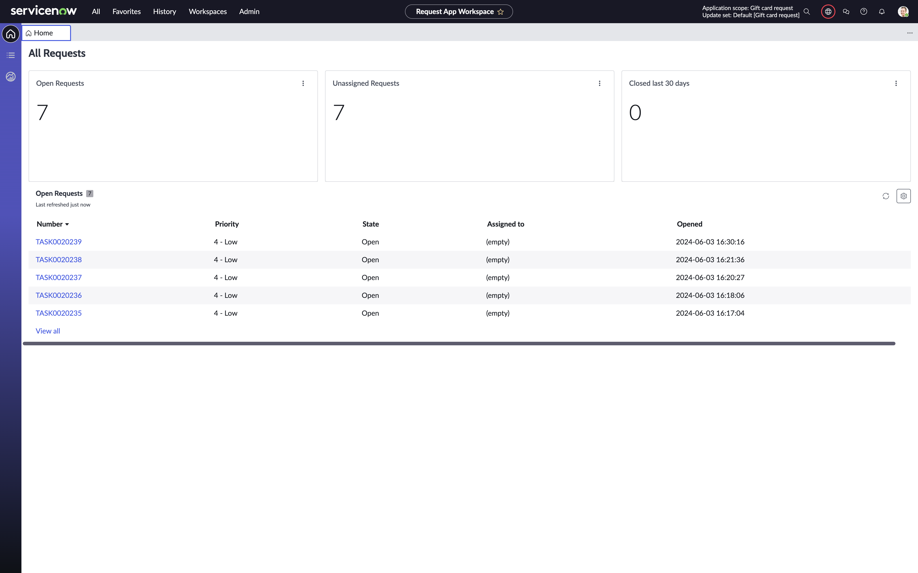

As you see, my workspace has a few tasks, yours will likely have only one.

1. Click to view the task Billie Cawley just submitted, in my case it’s **TASK0020239** (your number will be different – but check the time stamp and you will see it’s the correct one for you).

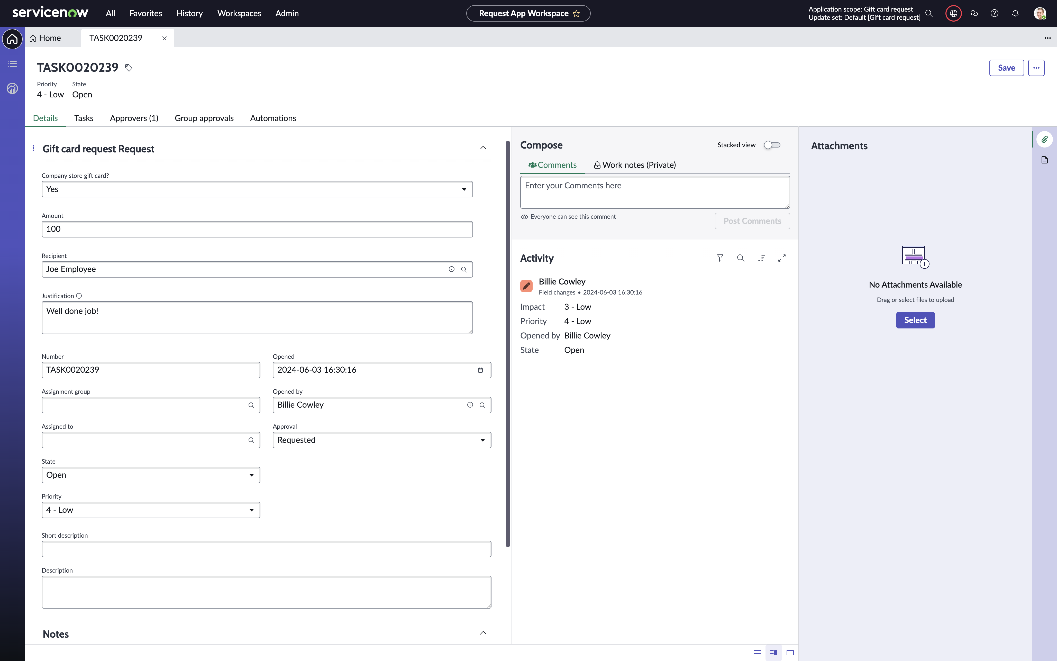

In here, we can see that Billie created the request (opened by), we can see the various data points she entered before submitting.

We an also see that the approval state of the request is **Requested.**

1. Click the **Approvers** related list near the top of the record and then also the **Automations** related list.

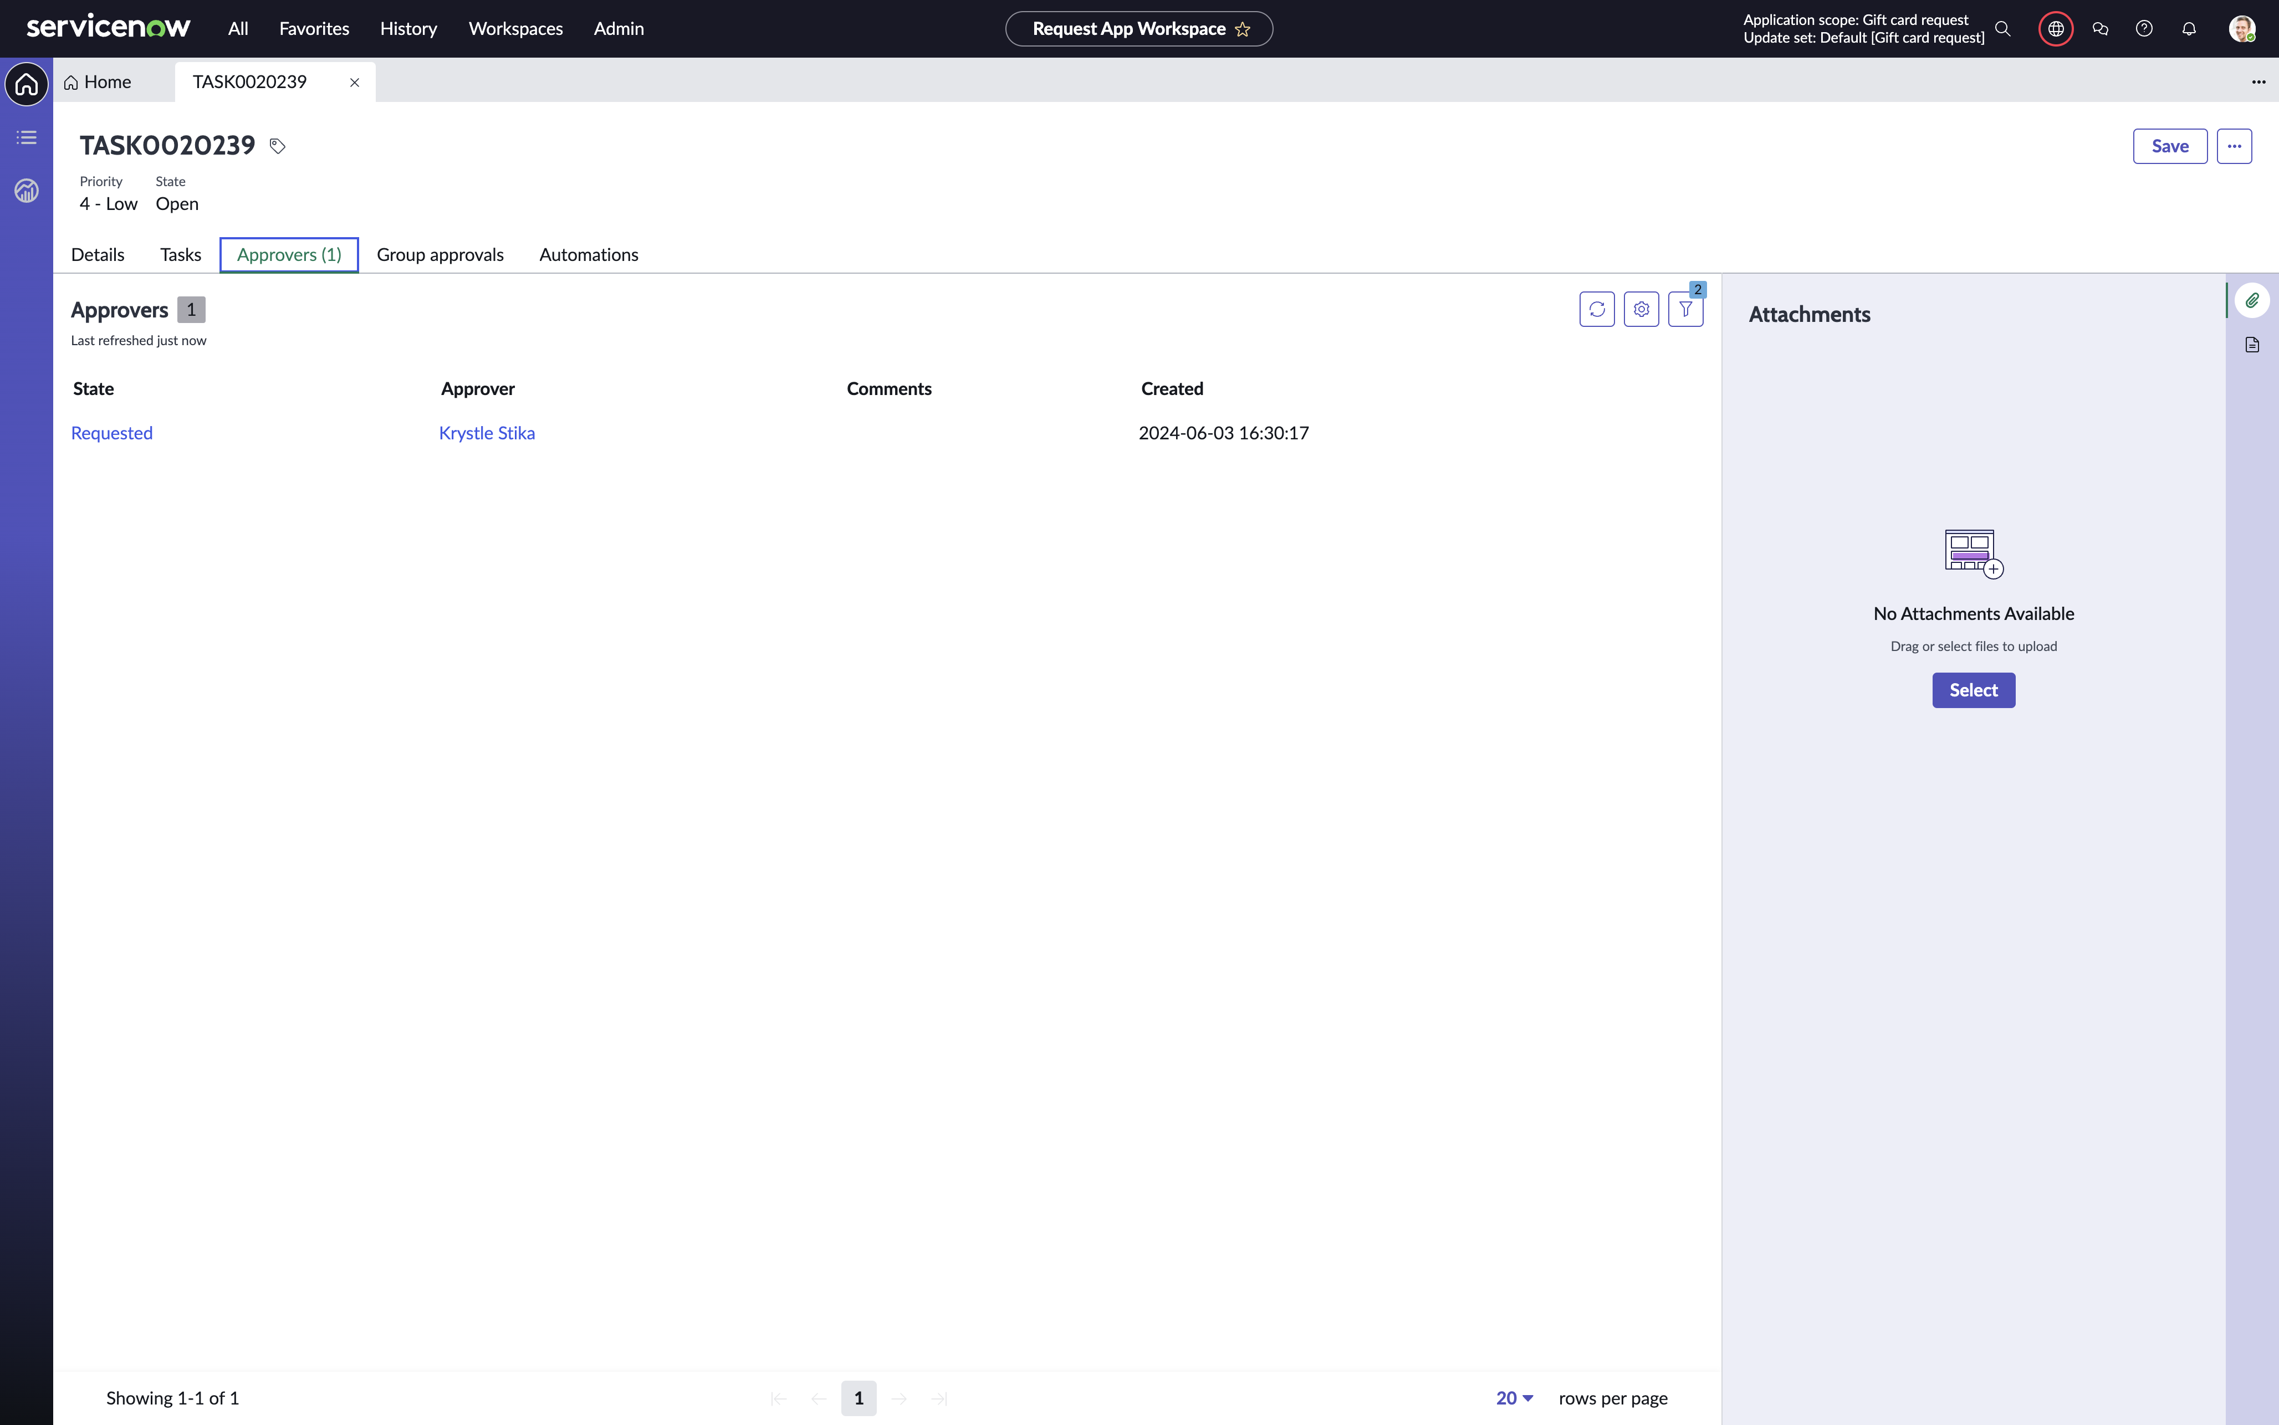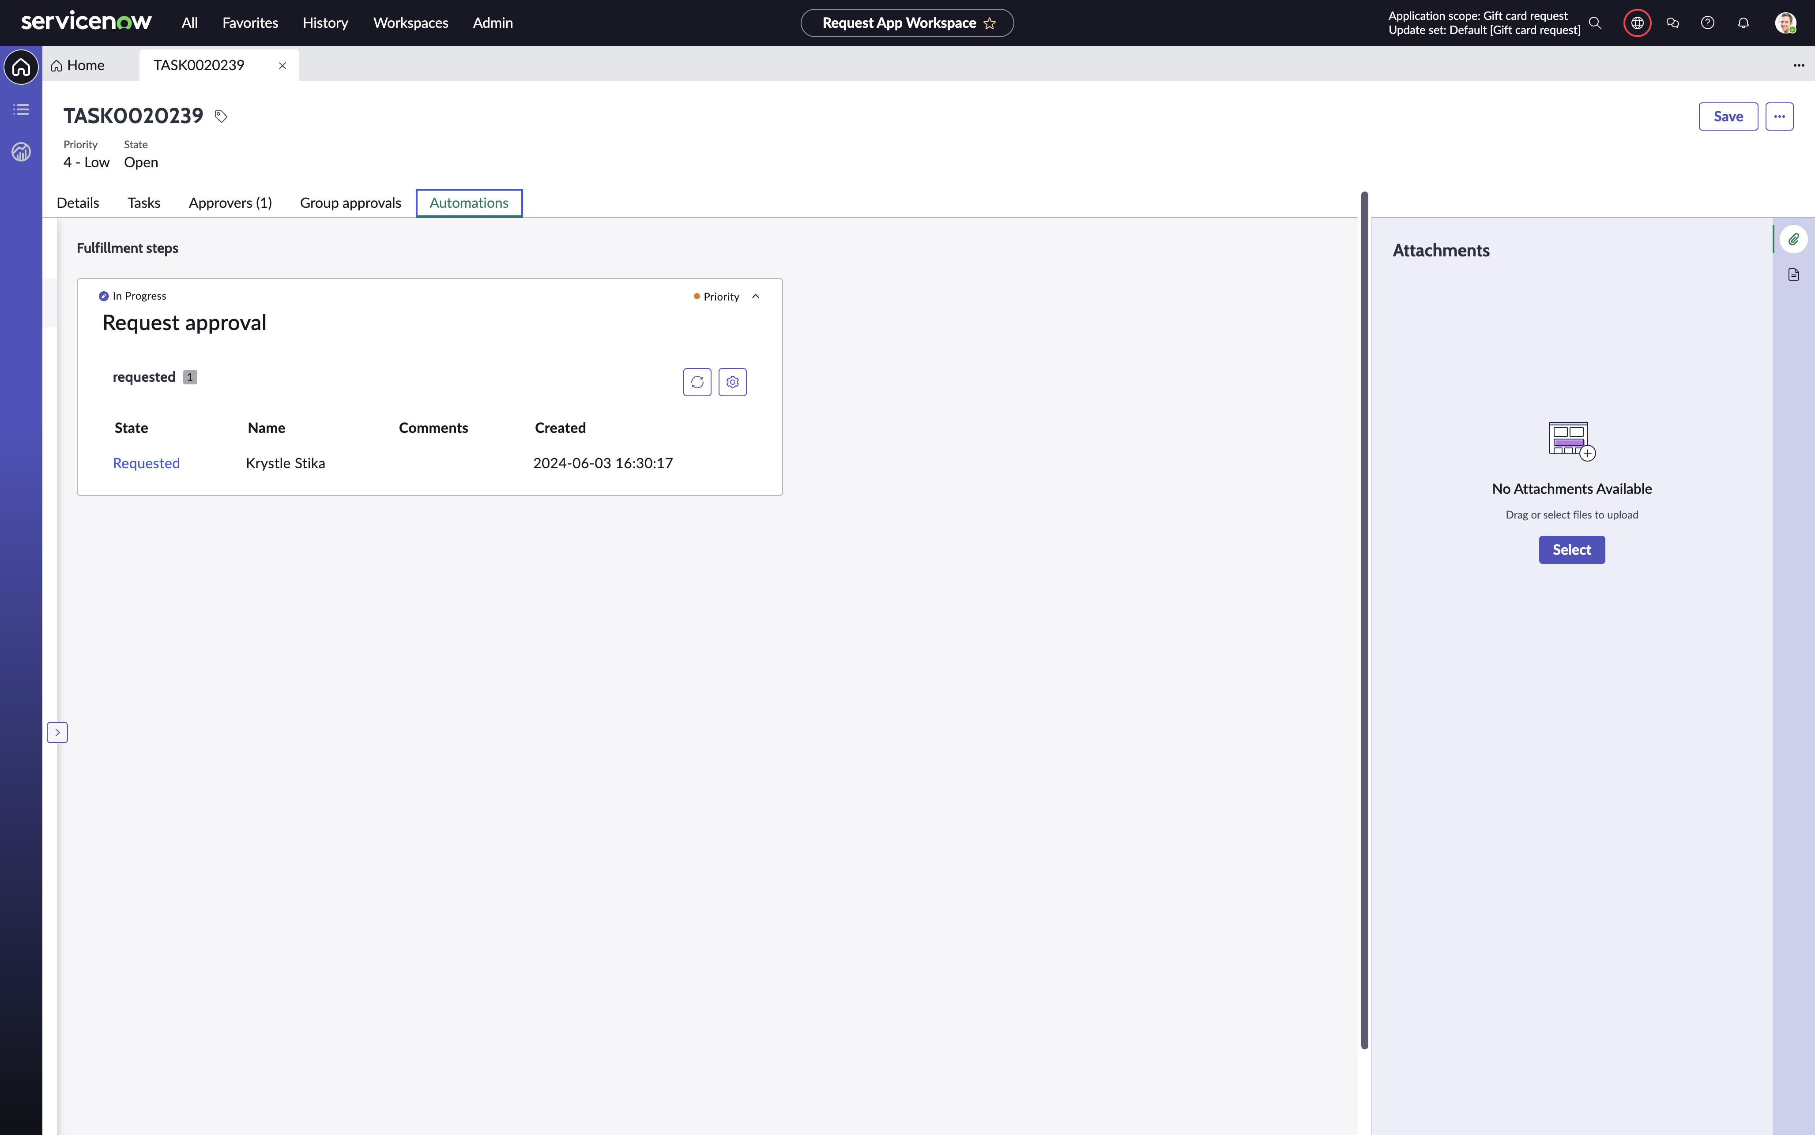

Observe that **Krystle Stika** has been assigned an approval of this request. She is the manager of Billie.

The **Automations** related list shows any automation step you build out in the Playbook. Steps here can also be for the process user – the playbook guides the user what to do.

Conclusion

You have now in about 45-60 minutes created an application in ServiceNow using the new **Creator Studio**.

Your application contans a table to hold your request data, a catalog item for your users to submit their request, an automation to manage approvals and potentially other important steps for the process. Lastly, a workspace for the process users to have an overview of the processes assigned to them.

**This completes the Lab**

**Thank you for your participation!**

/Your ServiceNow team

You can read more on all our solutions at  
https://www.servicenow.com/workflows/creator-workflows.html